Article 460 Review of an Academic Research Project “as Done”
Guillermo Sánchez Sotés
Manchester School of Architecture, UK • g.sanchez.sotes/at/mmu.ac.uk
Thomas Fischer
Southern University of Science and Technology, China • tfischer/at/sustech.edu.cn
Christiane M. Herr
Southern University of Science and Technology, China • cmherr/at/sustech.edu.cn

Structured Abstract
Article type: Application (of constructivist concepts and insights to an applied discipline).
Background(s): Educational research
Approach: Second-order cybernetics
Context: This study investigates the difference between research “as done” and research “as reported” as a specific instance of the broader distinction between embodied experience and its description.
Problem: Despite a long-standing tradition within the philosophy of science that views research as a complex and often messy process, designers and architects have tended to neglect this discourse, favoring instead superficial claims of objectivity often associated with scientific research. Consequently, reports on architectural and design research tend to omit unexpected insights or failures encountered along the path of inquiry, creating the misleading impression that outcomes emerge automatically along rational and deterministic processes.
Method: We provide an account of the first author’s recently conducted PhD project, aiming to faithfully portray an academic research project “as done” and relate this portrayal to its formal report.
Results: We draw on discussions within the philosophy of science and design research to exemplify the conceptualization of academic research as an uncertain journey, thereby aligning design and architectural research with constructivist approaches. This highlights the potentially mutually enriching relationship between the lived experience of inquiry and its portrayal in formal reports while acknowledging the inherent distinctions between the two.
Implications: We hope that this study will benefit researchers, particularly early-career architectural researchers. The latter, whose studio upbrinnging emphasizes similarities across all forms of open-ended inquiry, may be misled into believing that good research is based entirely on rational and linear processes of inquiry, as it often appears when viewed superficially through the lens of formal research reports.
Constructivist content: The work presented here puts forward a personal journey of constructing academic research through exemplifying and accounting for various mismatches between research “as done” and research “as reported.” This exemplification highlights aspects of the research process that are often overlooked or omitted in favor of ease of research consumption.
Key Words: academic research, as done, as reported, design research, research

Introduction
- Situating design research within the realm of academic research, Ranulph Glanville (1999: 80f) presents an argument that restores design to what he argues is its rightful place in research. He asserts that research should be viewed as a “(restricted) design act, rather than design being inadequate research” (Glanville 1999: 81). In this context, Glanville highlights a divide between research “as done” and research “as reported” – echoing Reichenbach’s (1938) distinction between the context of discovery and the context of justification. In Glanville’s view, research is commonly understood “to produce extendable and testable social knowledge” (Glanville 1999: 81). To this end, we researchers “take our knowledge, extend and test it until it ‘breaks, ’ and then rebuild it” (Glanville 1999: 81). This circular process of extension, failure, and “rebirth” is fundamental to the research endeavor. However, reports of this process in design and architectural research are often post-rationalized, presenting explanations that are likely experienced rather differently (Glanville 1999: 81; Latour & Woolgar 1986: 28f; Medawar 1964: 42f).
- Alberto Pérez-Gómez (1983), in Architecture and the Crisis of Modern Science, contends that architects have invoked rationality as a means of positioning architecture as an academic discipline. Aligning himself with this perspective, Glanville (1999: 80) critiques the context in which architectural and design research emerges, explaining that science “was seen as so successful that everything should be scientific: the philosopher’s stone! Architects (a significant subdivision of designers) were determined to become scientific.” Architecture, far from being defined by a singular set of concerns, embodies a multifaceted amalgamation of diverse approaches and perspectives. Mark Linder (1992: 167) highlights this complexity, observing that “architecture’s limits prove elusive and theoretical attempts to understand architecture inevitably appeal to the authority of disciplines perceived to be more universal or nimble than architecture.” In their pursuit of academic legitimacy, architects have frequently appropriated processes, claims, and ideas – often in a superficial manner – to frame architecture as rational and marketable (Sanchez Sotes 2024). This alignment with the perceived objectivity of scientific research has, in turn, led architects to distance themselves from the inherently subjective and iterative nature of architectural practice and inquiry.
- While aligning with superficial claims of objectivity often associated with scientific research, designers and architects tend to overlook the extensive discourse within the philosophy of science, which emphasizes that research is a complex, multidimensional, and frequently messy process influenced by broader societal forces and constraints (see, for example, Kuhn 1970). Glanville (1999: 80) critiques this tendency among architects, suggesting that they have adopted a superficial approach that neglects crucial discussions in their efforts to render architecture and design scientific: “It did not matter that science, as practiced, was not as described in both scientific publication and in the philosophy of science, or that the philosophers were debunking these understandings.”
- This study thus aims to align design and architectural research with constructivist approaches by providing an account that faithfully portrays an academic research project “as done” and relates it to its formal report. The research draws upon the first author’s recently conducted PhD thesis in architecture. Reflecting on this process, we take Glanville’s (1999) observations on the distinction between and the challenges inherent in research “as done” and research “as reported” to exemplify the conceptualization of academic research as an uncertain journey rather than an entirely rational and deterministic process. Furthermore, this exemplification underscores the potentially mutually enriching relationship between the experience of inquiry and its portrayal in reports. However, in writing this article, we face the inescapable conundrum that we cannot report our way out of the gap between experience and reporting on experience.
- Notwithstanding this inescapable conundrum, we hope that the exemplification and account of the various mismatches between research “as done” and research “as reported” presented in this study will benefit researchers in general and architectural early-career researchers in particular, who may have been misled into believing that good research is based entirely on rational and linear processes of inquiry, as it often appears when viewed superficially through the lens of formal research reports. By demonstrating the mechanics of conducting research and illustrating sources of unpredictability, we aim to reassure early-career researchers in architecture and related disciplines that losing a sense of orientation during the process of doing research is both common and acknowledged – much like the iterative nature of the design process.
- In the following two sections, we contextualize and review prior research relevant to the distinction between research “as done” and research “as reported.” The subsequent section will provide a summary of the first author’s recently conducted PhD thesis “as reported,” followed by a faithful account of his PhD journey. This article concludes with a critical analysis of and reflections on what is lost and gained when post-rationalizing research to make it consumable, particularly within the context of architectural research and neighboring disciplines. It also discusses the implications of this practice for academic researchers in general and for early-career architectural researchers in particular.

“Context of Discovery” and “Context of Justification”
- The term “research” is derived from the Middle French “recherche,” which means “to go about seeking” the unknown. This pursuit aims to “increase our knowledge (of the world)” (Glanville 1999: 81) or, as Glanville further clarifies, to increase our “knowing,” emphasizing the active role of the researcher rather than viewing knowledge as being separate from the knower. Researchers typically engage in this pursuit by taking established knowledge, testing it until it “breaks,” and then rebuilding it, thus extending previously established understandings (Glanville 1999: 81). This process, as Glanville (1999: 81) describes, is the essence of doing research. The outcomes of this process are generally expected to be stable, repeatable, and unambiguous, thereby contributing to the collective production and development of knowledge. Additionally, research outcomes should be coherent and fit within the existing body of knowledge, enabling others in the field to understand and build upon them. This process of putting observations of “objective” outcomes into a structured account of the research is what Glanville refers to as the report of research.
- An equivalent distinction to that between research “as done” and research “as reported” is that between the “context of discovery” and the “context of justification” (Reichenbach 1938), which has been one of the cornerstones of the philosophy of science since the beginning of the 20th century. Hans Reichenbach coined this distinction in his 1938 Experience and Prediction to differentiate between the development of scientific theories and their rational reconstructions (Reichenbach 1938). Notably, Karl Popper had previously articulated a similar distinction by drawing on Kant’s notions of quid facti and quid juris, distinguishing between Tatsachenfragen (“questions of fact”) and Geltungsfragen (“questions of validity”) in the English edition (Popper 1959) of his seminal work Logik der Forschung (Popper 1934).
- Focusing on how research should be done, George Pólya (1945), within the field of heuristics, provides practical guidance intended to enhance the active pursuit of knowledge. His approach aimed at refining problem-solving techniques. Unlike the formalized methodologies of logical positivism, Pólya’s heuristics emphasize a flexible, iterative approach that aligns with the dynamic nature of scientific discovery.
- This focus on flexible strategies for problem-solving contrasts with the formalized accounts of scientific rationality advocated by Reichenbach, who defines the “context of discovery” as the underlying cognitive processes through which scientific knowledge is generated, and the “context of justification” as the rational reconstruction and validation of that knowledge. For Reichenbach, the context of justification provides a refined and systematic account of what occurs in the context of discovery, rendering the latter irrelevant to the formal structure of science (Aufrecht 2010). However, Thomas Kuhn challenges this distinction, which was originally intended to separate “the social and psychological facts surrounding the discovery of a scientific hypothesis from the evidential considerations relevant to its justification” (Salmon 1970: 68). Kuhn (1996) argues that if a scientist’s judgment is deeply influenced by the prevailing norms of their paradigm, it becomes impossible to fully disentangle the evaluation of evidence from the historical and social context in which the theory was developed – particularly insofar as this context is defined by the specific paradigm in question. Karl Popper (2000: 142) emphasizes that “science is impossible without experience (but the notion of ‘experience’ has to be carefully considered),” critiquing the notion that scientific knowledge is never final or complete. Building on Popper’s critique, Paul Feyerabend (1958) rejects rigid attempts to systematize the data of human experience, advocating instead for methodological pluralism.
- Like Reichenbach, Imre Lakatos seeks to distinguish rational reconstructions from the employed methodologies in scientific practice. Lakatos (1970: 106) argues for a shift away from reconstructions of the thinking processes of individual scientists, advocating instead for reconstructions that embody an idealized mode of the thinking processes – specifically, one that is logically coherent and rationally justified. If a scientist fails to follow the thinking process that a given methodology requires, Lakatos advocates replacing it with the “correct” thinking process in the rational reconstruction (Lakatos 1970: 107). In other words, he advocates replacing the thinking that is presumed to have occurred with the thinking that should have occurred. Kuhn (1970: 151f) explicitly rejects Lakatos’s reliance on such rational reconstructions, contending that philosophers of science should not depend on fictionalized episodes of scientific practice, as either evidence or illustration.
- Other perspectives on the contextual distinction between discovery and justification have extended beyond purely logical and epistemological dimensions to include broader social, cultural, and political frameworks. Karin Knorr-Cetina (1999: 8), for instance, demonstrates how the production of knowledge is influenced by “epistemic cultures,” which encompass not only disciplinary practices but also the implicit norms, hierarchies, and institutional structures within scientific communities. These epistemic cultures reveal that what is regarded as scientific rationality is not detached from its socio-historical context but is intrinsically intertwined with the interests, values, and power dynamics of the groups involved.
- From an economic and political dimension, Mats Alvesson and Jorgen Sandberg (2021), argue that traditional research frameworks often align with prevailing socio-economic priorities, thereby privileging certain avenues of inquiry over others. For example, the commodification of research within neoliberal paradigms tends to prioritize projects that promise measurable outcomes or commercial applications, frequently at the expense of investigations into more abstract or politically contentious issues. Knorr-Cetina (1999) expands on this critique, illustrating how global networks of researchers, funding bodies, and policymakers collaboratively influence the direction and justification of scientific endeavors.
- Most of these perspectives thus challenge earlier notions of rational reconstructions as static or universally applicable, instead revealing the contingent and negotiated nature of knowledge validation within specific contexts. Furthermore, they recognize research as a complex, multidimensional, and often messy process shaped by broader societal influences and constraints.

Research “as done” and research “as reported”
- According to Glanville (1999: 82), research is conducted in two main arenas: experiment and theory. “Experiments are the main means by which scientists extract knowledge of the world we inhabit. They do this by radical simplification,” often neglecting the role of the experimenter (Glanville 1999: 82). Nonetheless, it is the experimenter who chooses to conduct the experiment, sets it up, observes and determines the outcomes, and decides on subsequent actions. This process of embodied experience is inherently circular, often leading to unexpected insights or failures (Glanville 1999: 83). Similarly, in the second arena, the process of building theory is a self-referential act and, therefore, necessarily circular.
- In Glanville’s view, “(scientific) research (whether experiment or theory) is a design activity. We design experiments, but we also act as designers in how we act in these experiments” (Glanville 1999: 88). The manner in which designers do this is circular-conversational (in Gordon Pask’s 1975 sense): we act and test iteratively until reaching “something satisfying our desires – for stability/recognizability/repeatability/etc.” (Glanville 1999: 88f). Therefore,
“the role of observer-as-participant, in making knowledge, abstracting it to theory, theorizing about theory; and in constructing the way we obtain this knowledge, then obtaining it accordingly, is central/essential/unavoidable/inevitable and completely desirable. Without the active participation of this actor, there would be nothing that we would know. At every step, in every action, the observer/participant is actively designing. There is nothing passive, automatic, or without person (agent, scientist, or designer) here.” (Glanville 1999: 88f)
- An observer researching is thus a human being capable of making distinctions (Maturana 1970: 4). According to Humberto Maturana (Maturana & Varela 1980: xix), making distinctions is “the basic cognitive operation that we perform.” In his view, by observing, an observer distinguishes entities from himself and the general background. Within “hard science” (i.e., mathematics, physics, chemistry, among others), scientists argue for and assume that observations can attain “objectivity” by separating observers from their observations. This objectivity is achieved by agreeing upon similar descriptions when observing the same phenomena (Dent & Umpleby 1998: 513–518). However, Maturana, Ricardo Uribe and Sam Frenk (1968: 1) question this assumption in their investigation of the nervous system, claiming that each observer’s reality is shaped by their past experiences. Similarly, Michael Polanyi (1974), through his notion of “Personal Knowledge,” highlights the pivotal role of the observer’s perspective, immediate experience, and actions in shaping knowledge and reality, thereby contesting the traditional ideal of detached objectivity. According to Maturana (1970: 4; 1975: 315; Maturana & Varela 1980: 8f) and second-order cyberneticians such as von Foerster (2003) or Pask (1975), every observer’s distinction is processed by the observer’s own actions and understanding (thoughts) recursively. It is this recursive relationship between “observer (observing) and observed” that is understood to be circular (Glanville 2012: 176).
- In Maturana’s view (Maturana 1980: 46f; Mingers 1995: 13f), the observer’s “choice and purposes” determine the description and explanation of distinctions or the conditions under which the observed phenomenon is generated. As a result, the observer is no longer separated from the system but instead becomes a part of it, being “appreciated and acknowledged rather than disguised” (Glanville 2012: 175; see also Dent & Umpleby 1998: 513–518). The observer is thus “able to interact independently with the observed entity and with its relations” (Maturana 1970: 4; Maturana & Varela 1980: 8). While the process of doing research involves a recursive interaction between the observer (as part of the system) and the observed (system), the reports of research commonly present observations from experiments or theories without acknowledging the act of observing and the observer. At the end of the 17th century, the Philosophical Transactions of the Royal Society, the journal of the Royal Society of London, pointed out that scientific language should be an “accurate language of description” (quoted in Forty 2000: 76). The Royal Society emphasized that scientific language was not adequate if the language used to report scientific experiments distorted them “or was untruthful to the findings” (quoted in Forty 2000: 76). Since then, scientific theories have assumed the form of objective statements that deliberately avoid inclusion of the observer’s experiences, emotions, or feelings. Instead, their primary objective is to accurately describe specific characteristics or properties of observed phenomena within particular space-time contexts, while commonly disregarding the act of observing itself (Montgomery 1996: 2–5; Morris 1946: 297).
- In this view, science “rejects, or at least is unable to cope with, the richness and ambiguity of symbolic thought” (Pérez-Gómez 1983: 6). Yet, it ensures that experimental results can be tested, confirmed, or falsified, making language “merely an instrument” – a transparent and neutral “medium of thought” (Barthes 1989: 4). It is thus not surprising that Galileo expressed that “the book of nature is written in the language of mathematics” (Kantorovic 1993: 59) and that Pearson advocates for the “striv[ing] at self-elimination” of scientists’ judgment (Weizenbaum 1976: 25). Figure 1 shows our interpretation of Glanville’s distinction between research “as done” and research “as reported.”
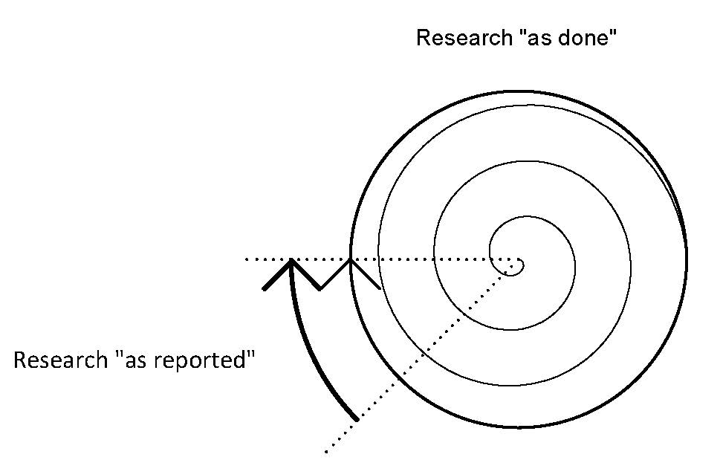
Figure 1: Our visual interpretation of Glanville’s distinction between research “as done” and research “as reported.”
- The “traditional view” of research in which “there is … a ‘right’” (Glanville 1999: 84) involves defining a problem, executing specific procedures, and assuming that “the resulting output from the scientific machine must be correct” (Glanville 1999: 84). The “traditional view” Glanville is referring to is logical positivism (see Glanville 2012: 194), which assumes that observation of an accessible objective reality, in combination with logical reasoning, can lead to “correct” and formally “representable” knowledge. This view, in essence, relies on rational and linear processes of inquiry, portraying research in a reductionist manner where an ordered, rational, and deterministic narrative is fabricated from disorder and chaos (Latour & Woolgar 1986: 244–258) or, as Schön (1983: 25) describes, from “situations characterised by uncertainty, disorder, and indeterminacy.” As Jerome Ravetz (1973) suggests, this form of presentation is not a useful way of characterizing scientific activity. Such portrayals are “neither accurate nor credible – either about how we do research, or the response/output we can reasonably expect” (Glanville 1999: 84). Peter Medawar (1964: 43) asserts that this approach is “a fraud in the sense that it does give a totally misleading narrative of the processes of thought that go into the making of scientific discoveries.”
- In essence, the reductionist presentation of research can potentially create the impression that research outcomes appear automatically, omitting instances of deviation or failures encountered by the researcher along the path of inquiry. As Michael Hohl (2018: 249) notes when reflecting upon his own PhD experience, “the individual creative process involves necessarily subjective, intuitive and explorative phases in which adhering to ‘objectivity’ might be more of a hindrance” (Hohl 2018: 249). Glanville’s differentiation between research “as done” and research “as reported” thus seems to parallel the distinction between embodied experience and its textual description, illustrating a specific instance of this broader divide.

A summary of a research project “as reported”
- In the first author’s PhD thesis, entitled The Appropriation of Autopoiesis in Architecture (Sánchez Sotés 2024), he (hereafter referred to as “I”) investigates the merits of cross-disciplinary appropriations of natural scientific theory in architecture, particularly of the theory of autopoiesis as appropriated in Patrik Schumacher’s two-volume tome The Autopoiesis of Architecture (Schumacher 2011, 2012). The reported thesis consists of five chapters, which I outline in the following paragraphs.
- The introductory Chapter 1 presents the background, relevance, research questions, research scope, and research methods of the thesis. Furthermore, it outlines the structure of the thesis and explains key terminology used in it. Specifically, it offers a reflection on how architects and urban planners inhabiting fast-developing cities in China cannot fail to notice, and may find themselves captivated by, the seemingly biological growth and development of their urban surroundings.
- To the involved observer in the urban environment, the large-scale high-rise and street-level dynamics appear highly interdependent. These interrelations between manifestations of urban life at different scales seem to be characterized by the kind of systemic closure and interdependence that also characterize the interrelation between chicken and egg. Once initiated, arising from these relationships, urban growth appears to be a continual process of self-development and self-maintenance. With biological terms such as growth, development, and self-maintenance entering interpretations of urban dynamics, the idea emerges that architectural development may be approached via an understanding of biological development. This view gives rise to an obvious-yet-vague connection between urban dynamics and biological concepts – a sensation of this-is-like-that is not only intriguing but also profoundly related to how new understanding is gained.
- Chapter 2 reviews prior research relevant to the research interest presented in Chapter 1. It starts from the examination of previous discussions of adoptions of natural scientific theory (and related terminology) in the field of architecture. The urban environment and its various aspects are often elucidated with references not only to natural phenomena but also to concepts that originate from natural scientific theory (Collins 1998: 148; Forty 1999: 213; 2000: 97; Steadman 2008: 8). A possible explanation for this is that “cities are complex entities that are never entirely stable, always in a state of flux, growing, decaying, or dying” (Verebes 2014: 13), thereby inviting explanations in terms of knowledge that deals with just such patterns, that is, explanations in terms of natural scientific theory. Biological imagery and theories thus feature frequently in descriptions of urban environments (Kostof 1991: 52f; Lynch 1981: 88). Cross-disciplinary appropriations from biology to architecture are used not only to describe and explain but also to inspire and inform creative processes. For example, Frei Otto (1995) draws insights from bone structures to guide the creation of lightweight architectural designs.
- Other examples of the cross-disciplinary appropriation of biological concepts in architecture and urbanism reviewed in this chapter include the notions of metabolism, symbiosis, catalysis, homeostasis, coevolution, and autopoiesis, among others. These appropriations of scientific concepts often occur as a matter of course, gravitate toward biological ideas and theories, and provide stimuli for the creative development of architectural projects and the architectural discipline itself. Utilizing such “unauthorized jargon” (Scruton 1983: 26f, quoted in Johnson 1994: 44), architects establish a “metalanguage” for the proactive exploration of new conceptual connections, thereby enabling the formulation of design proposals and theories (Johnson 1994: 44). Hence, figurative connections to other fields should not be “immediately abandoned” as useless or entirely misleading (Steadman 2008: 5). However, as Adrian Forty (1999: 213) points out, “we should not assume that a scientific term, just because it comes from science, is a successful metaphor for architecture.”
- The literature review reported in this chapter subsequently focuses on examining the biological theory of autopoiesis as one of several natural scientific theories appropriated in architecture. The term autopoiesis was coined by the Chilean neuro-biologists Humberto Maturana, Francisco Varela, and Ricardo Uribe in the early 1970s to describe the organization of living systems (Maturana & Varela 1980; Varela, Maturana & Uribe 1974). The team describes living systems as closed networks of invariant, circularly causal relationships among their various kinds of constituent components. From resources available in their environments, these networks can produce and incorporate further components, allowing living systems to regenerate and reproduce while (and despite) also being subject to disintegration (Maturana & Varela 1980; Varela, Maturana & Uribe 1974).
- Since its inception in biology, the theory of autopoiesis has been given various interpretations and used to describe a range of different phenomena beyond biology (Bunnell & Riegler 2022: 3; Varela 2018: 9–12). Most prominent among these adoptions is Niklas Luhmann’s use of autopoiesis to construct a “macro” theory of society (Scott 2021: 63). Luhmann (1982: 131f) characterizes systems such as art, science, or politics as closed autopoietic systems of self-referential communications that reconstitute and reproduce themselves. Based on Luhmann’s academic theory, Patrik Schumacher, the principal architect of Zaha Hadid Architects and an educator at multiple architecture schools, has appropriated the concept of autopoiesis in architecture. In 2011 and 2012, Schumacher published his self-proclaimed “opus-magnum” – a two-volume theoretical treatise entitled The Autopoiesis of Architecture (Schumacher 2011, 2012).
- This literature-review chapter proceeds by reporting how, upon reading this work, I find myself uncertain in three regards: (a) While Schumacher positions his theory as a subset of Luhmann’s appropriation of autopoiesis – that is, describing architecture as a closed, self-referential communication system – rather than as a direct descendant of Maturana et al.’s theory of living systems, his appropriation does not break away unequivocally from the biological origins of autopoiesis theory. Multiple passages of Schumacher’s work left me wondering to what extent it explains architecture in terms of living systems, in terms of communicating social systems, or both; (b) Schumacher presents his theory of autopoiesis as an ostensibly rigorous academic “discourse analysis.” Yet, he proposes it in conjunction with his own architectural “epochal style,” with the ambition to push the current convergence in architecture’s avant-garde – Parametricism – into the mainstream as an inevitable long-term stylistic successor to Modernism, leaving me wonder whether Schumacher contributes a theoretical description, promotes a personal agenda, or both; (c) Further compounding (a) and (b), Schumacher does not seem to commit clearly either to the ambiguous, evocative, and metaphorical modes of writing architects tend to use to inspire or describe creative practice or to the analytical and unambiguous modes of writing academic researchers tend to use in their formal communications. Facing these ambiguities, I conclude this literature-review chapter by asking: What are the merits of Patrik Schumacher’s appropriation of the theory of autopoiesis? (Sánchez​ Sotés, Herr & Fischer 2022).
- Chapter 3 contextualizes and reviews the research methods to inquire into the merits of Schumacher’s theory appropriation. To this end, I developed and subsequently applied a purpose-designed approach, drawing primarily on methods developed earlier in the field of discourse analysis but also incorporating previously proposed categorizations of language use and merits of theory appropriation into a unified methodological framework (Sánchez​ Sotés, Fischer & Herr 2025).
- This research-methods chapter reports how I systematically analyze The Autopoiesis of Architecture. In it, I describe how I sample key passages that draw explicit or implicit connections between autopoiesis and architecture from the source material, which consists of the two volumes Schumacher published in 2011 and 2012. In my reading, a total of 16 theses meet these criteria – 9 theses in Volume I and 7 in Volume II. Employing close reading and inference to the best explanation, I analyze these samples and locate their references to autopoiesis in a two-by-two matrix formed by two overall distinctions.
- Firstly, I distinguish references to two previous instances of autopoiesis theory:
- References to Luhmann’s theory of autopoiesis in social systems. As Schumacher leans on Luhmann’s theory directly by explicitly positioning architecture as a social system in Luhmann’s sense, I take these references to autopoiesis to be literal.
- References to Maturana et al.’s biological theory of autopoiesis. Since Luhmann’s theory (which Schumacher leans on) refers to Maturana et al.’s theory of autopoiesis loosely, I take these references to autopoiesis to be figurative. I furthermore differentiate these figurative references into several modes of language use (besides the above-mentioned literal use), namely, simile, metaphor, analogy, metonymy, and synecdoche.
- Secondly, I distinguish between two possible benefactors of Schumacher’s appropriation of the theory of autopoiesis in this context:
- Me, seeking to understand connections between the built environment and living systems.
- Patrick Schumacher (P.S.), putting forward a theory of architecture. The matrix is shown in Figure 2.
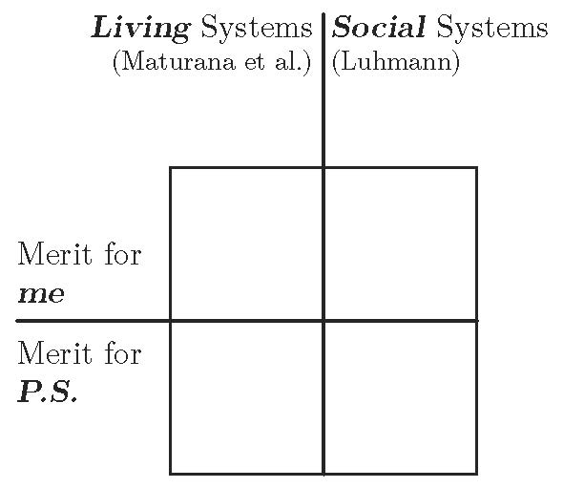
Figure 2: Two-by-two matrix allowing the placement of samples based on referenced preceding theories and theory beneficiaries of theory appropriation.
- After placing the sampled references to autopoiesis theory within the two-by-two matrix formed by these two overall distinctions, I further qualify them based on a categorization of motivations (which we refer to as merits) of theory appropriation in architecture put forward by Michael Ostwald (1999). This categorization comprises the merits of legitimization, obfuscation, explanation, transmission, theorization, equalization, occupation, and accommodation. Besides categorizing and placing sampled references to autopoiesis theory in the two-by-two matrix described above, I also associate each reference with a type of language use as well as with one or more of Ostwald’s categories. In this analysis, a reference to autopoiesis may be categorized, for example, as a metaphorical obfuscation or a literal equalization. Finally, after sampling, analyzing, and categorizing each passage, I superimpose all placements in the two-by-two matrix shown in Figure 2 onto a single two-by-two matrix to establish an aggregate pattern of language uses and merits across all samples.
- The thesis continues with Chapter 4, which documents the complete analysis of Schumacher’s appropriation of the theory of autopoiesis in architecture as presented in his two-volume The Autopoiesis of Architecture. This analysis follows the methodological approach outlined in Chapter 3 and aims to answer the research question posed at the end of Chapter 2. Given the constrained space available here, we refrain from providing a detailed analysis of the selected samples. For a complete examination of the 16 analyzed passages, please see Sánchez​ Sotés (2024).
- The concluding Chapter 5 consolidates the outcomes of the thesis, offering answers to the research question posed at the end of Chapter 2, alongside related reflections and contextualizing observations. The superimposition of references to autopoiesis in the sampled passages indicates that the connections Schumacher draws between architecture and autopoiesis do not adhere to a uniform use of language. Instead, the use of language in the sampled passages ranges across literal, metaphorical, analogical, similized, and metonymical modes. This mix of figurative and literal use of language, evocative and inspiring from a creative point of view, is challenging to grasp from a more formal academic viewpoint.
- The merits of Schumacher’s references to autopoiesis, likewise, range across the full spectrum of motivations for theory appropriation proposed by Ostwald (1999). Yet, in my reading, a considerable portion of these merits fall into the obfuscating, legitimizing, and equalizing categories, in relation to which Ostwald (1999: 67), building upon Alan Sokal and Jean Bricmont’s work (2003: 178–182), stated: “nothing productive can result from appropriations motivated for these reasons.” Appropriations of these kinds tend to benefit the author rather than facilitating clarity of understanding on the part of the reader. While Schumacher relies explicitly on Luhmann’s theory, Figure 3 also shows that a considerable portion of the connections drawn between architecture and autopoiesis appears to relate, or at least does not preclude relating to, biological systems rather than exclusively aligning with social systems.
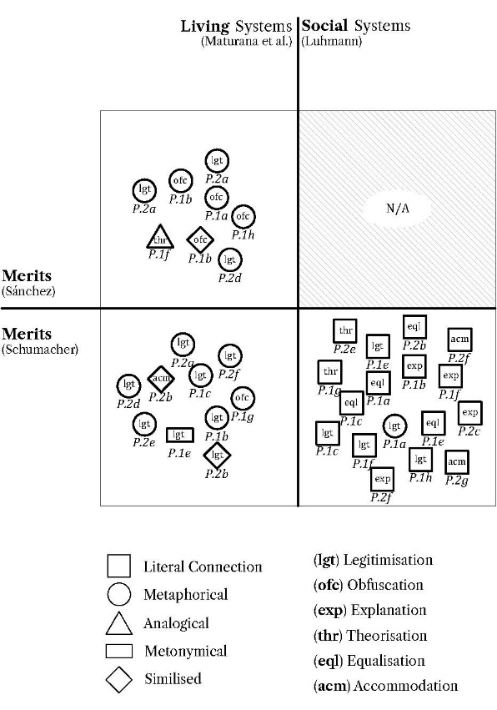
Figure 3: Superimposition of findings in a single two-by-two matrix.
- This concluding chapter further discusses the implications and contributions to knowledge of this thesis in the context of architectural research and beyond. It claims to hold value for other researchers, especially those with studio-design backgrounds and those at the beginning of their academic research careers, to contextualize, evaluate, and appreciate the extent to which figurative, designerly reasoning of architectural practice and literal, rational reasoning of academic research may (or may not) justifiably inform and enrich each other.

A faithful account of a research project “as done”
- While the previous section summarizes the first author’s recently conducted PhD thesis “as reported,” this section provides an account of his project as it was experienced by the first author (hereafter referred to as “I”), which was significantly different. The written thesis did not give a faithful account of how challenges were tackled and how new insights emerged but instead post-rationalized them (as we aim to illustrate in Figure 4, contrasting his research “as reported” and “as done”). Here, the first author presents three distinct moments of crisis that faithfully depict his PhD journey. These are instances where, as a learner, “you feel vulnerable; you feel you don’t know what you’re doing; you feel out of control; you feel incompetent; you feel that you’ve lost confidence” (Schön 1987, presentation to the 1987 meeting of the American Educational Research Association).
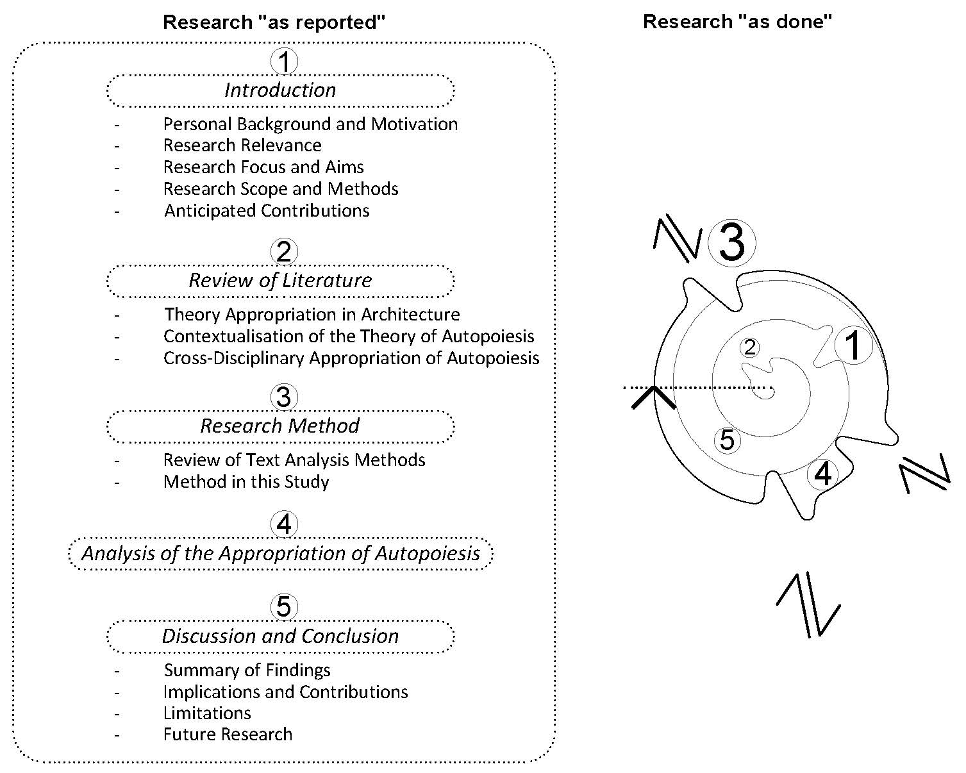
Figure 4: My PhD thesis “as reported” and “as done.”
- I embarked on my PhD journey with a background in architectural studio education and practice. With this background, I arrived at Suzhou Industrial Park (SIP), a county-level administrative area located in Suzhou, China, in 2017. My experience as a participant in, and an observer of, the social, cultural, and economic processes of this fast-developing urban center – captured in Figure 5 – became a key inspiration for the work presented in my PhD thesis.
- I arrived in this context intending to investigate the street-level production and use of these temporal and informal structures by way of participatory research-through-design. This proved prohibitively difficult for a combination of reasons: The language barrier between the local population and me, a native Spanish – as well as English – speaker; local suspicions toward outsiders inquiring into operations of often highly competitive and, in their physical presence, no more than tolerated and sometimes outright illegal structures; and, eventually, a decree by the Xi’an Jiaotong-Liverpool University (XJTLU) Graduate School in response to the COVID-19 pandemic that ongoing field PhD research projects be converted into lab or desk research projects.
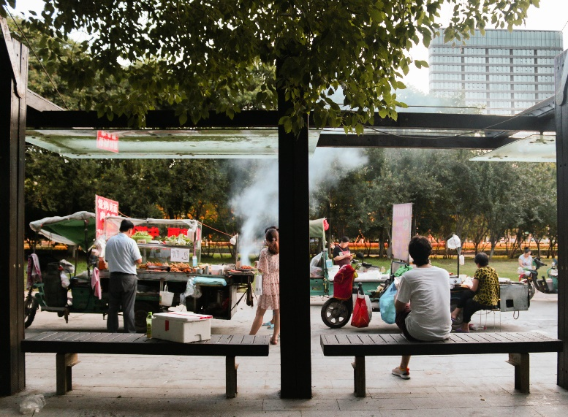
Figure 5: Me, a participant in, and observer of, fast-developing urban centers in China. (Photo by Sofía Quiroga.)
- In response to these factors and the bafflement I encountered while reviewing the literature – particularly the appropriation of the (biological) theory of autopoiesis by the architect Patrik Schumacher – I shifted my attention away from street-level participatory field research and toward more theoretical aspects of my interest in Chinese urban development. This initial dead end led to a sense of disorientation and a loss of enthusiasm for conducting research. The need to reorient my research focus, coupled with the necessity of discarding a significant amount of valuable and emotionally significant video and photo data collected during the first year of my PhD journey, contributed to this feeling. Despite my initial disappointment, the city became an on-ramp for exploring how designers and architects engage with and appropriate theory, as reported in Chapter 1 of my PhD thesis.
- Another moment of crisis occurred during the development of the analytical categories used to analyze the sampled passages from The Autopoiesis of Architecture. I developed these categories myself, guided by the methodologies proposed by discourse analysts Rosalind Gill (2000: 179) and Jonathan Potter and Margaret Wetherell (1987: 167). They suggest that each discourse analysis should construct its own categorization by starting with the initial research interest and question. Through a preliminary examination of the data set, the researcher can then expand or refine the categories (or themes) as needed for the analysis. Categorizations can sometimes be straightforward – for example, identifying mentions of a word or phrase linked to the nature of the research question. At other times, categorizations may not be as conspicuous and thus require some preliminary analysis (Gill 2000: 179; Potter & Wetherell 1987: 167).
- Within this context, I produced a list of two distinct categories: modes of language use and affordances of theory. The first category, which remains unchanged throughout the analysis, includes the subcategories of literal connection, simile, metaphor, analogy, metonymy, and synecdoche. These modes not only facilitate a connection between disparate concepts but also enhance the effectiveness of the text. They aid discourse participants in drawing powerful new insights while being equally capable of distorting the understanding of the appropriated theory. The second category encompasses the subcategories of convince, inspire, understand, explain, clarify, justify, and impress. These modes delineate the quality of theory, outlining its potential applications. However, midway through applying this framework to the analysis of The Autopoiesis of Architecture, I discovered a more appropriate approach – namely, Ostwald’s categorization of motivations of architectural theory formation through appropriation (Ostwald 1999: 66). This categorization comprises the merits of legitimization, obfuscation, explanation, transmission, theorization, equalization, occupation, and accommodation.
- Finding Ostwald’s work late in my PhD journey led me to question my effectiveness as a researcher, as it implied that I had overlooked an important part of the literature. However, Ostwald’s framework proved invaluable. It provided not only an established foundation upon which to build but also reassurance that investigating the motivations underlying theory appropriation in architecture is indeed significant. Recognizing its importance, I replaced my original categorization of affordances of theory with Ostwald’s categorization of motivations for theory appropriation. I further substituted his term motivation with the term merit to emphasize the benefits theory appropriations may offer users of appropriated theory (readers) rather than emphasizing the possible intentions of, and benefits for, appropriators of theory (authors). By changing this term, I acknowledge Heinz von Foerster’s (Foerster & Pörksen 1998: 112) postulation that “it is the listener [i.e., the reader], not the speaker [i.e., the author], who determines the meaning of an utterance [i.e., a text],” as well as Roland Barthes’s (1977: 148) calls for “the death of the author,” arguing that “the reader is the space on which all the quotations that make up a writing are inscribed without any of them being lost.”
- One of the most significant setbacks I encountered during my PhD journey stemmed from my own misreading of Schumacher’s appropriation of the theory of autopoiesis. I initially analyzed his work under the assumption that concatenated theory appropriation would inherently retain traces of the original appropriated theory. Specifically, I believed that since Luhmann’s concept of autopoiesis was derived from Maturana’s autopoiesis, and Schumacher’s interpretation of autopoiesis was based on Luhmann’s, then Schumacher’s autopoiesis must also be derived from Maturana’s original theory (i.e., if B = A and C = B, then C must equal A).
- However, this is not the case. Maturana et al.’s references to biological systems are (predominantly but with exceptions) literal in the sense that they describe evidently observable phenomena. Luhmann’s description of communication systems in terms of biological systems, however, is figurative in the sense that it describes communicative systems as being like biological cells. Schumacher’s description of architecture as autopoietic, in turn, is literal when read along Luhmannian lines (given that Schumacher positions his theory as a subset of Luhmann’s theory) and figurative when read along Maturanian lines (describing architectural discourse as being like biological cells). Figure 6 shows the different kinds of (literal or figurative) relationships within and among the three instances of autopoiesis.
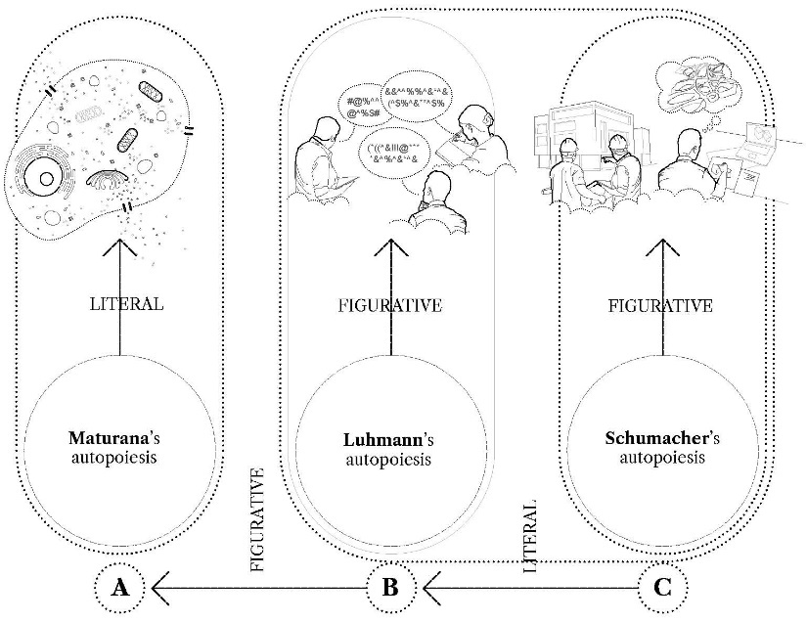
Figure 6: The different kinds of literal or figurative relationships within and among the three instances of the theory of autopoiesis.
- After initially blaming myself for not recognizing the disconnection between The Autopoiesis of Architecture and the autopoiesis theories of communication systems and biological systems from the beginning of my reading, I understood that it was not (only) due to my misinterpretation of Schumacher’s work. It was also due to Schumacher’s lack of interest in countering possible figurative references in line with Maturana et al.’s theory of autopoiesis and the built environment. This disconnection, therefore, featured prominently not only as an initial motivation in my thesis but also as a key aspect of its findings. Furthermore, the reported thesis also acknowledges this disconnection as a potential challenge to its credibility and trustworthiness. The credibility and the trustworthiness of a text analysis depend largely on the degree to which the perspectives of the author of the analyzed text, the analyzing researcher, and the readers of the analysis are aligned. The alignment of the perspectives of author and reader, however, also requires clarity on the part of the author. In this regard, I found The Autopoiesis of Architecture to be somewhat unclear.

Conclusion
- In this study, we build upon Glanville’s distinction between research “as done” and research “as reported,” contextualizing it within the equivalent distinction between the “context of discovery” and the “context of justification” (Reichenbach 1938). Within the philosophy of science, these concepts have long been used to underscore the inherently complex, multidimensional, and often messy nature of the research process. We argue that designers and architects have frequently overlooked this discourse, favoring superficial claims of objectivity commonly associated with the reporting of scientific research. To align design and architectural research with constructivist approaches, we exemplify this distinction through an exploration of the first author’s PhD thesis.
- By relating the formal report of the PhD to a faithful account of its research process, we conceptualize academic research as an uncertain journey rather than entirely a rational and deterministic process, as it often appears when viewed superficially through the lens of formal research reports. Furthermore, this study underscores the potentially mutually enriching relationship between the lived experience of inquiry and its portrayal in formal reports while acknowledging the inherent distinctions between the two. We illustrate this relationship of an academic research journey in Figure 7, drawing an analogy to the recurrent adaptations of an autopoietic system in response to environmental disturbances – a process Maturana and Varela (1980: xx–xxi) termed structural coupling (“conservation of adaptation”). However, in writing this article, we confront an inescapable conundrum: one cannot report one’s way out of the gap between experience and reporting. This conundrum underscores the inherent limitations of any attempt to fully capture the richness and complexity of lived research experiences within the structured confines of a formal report.
- 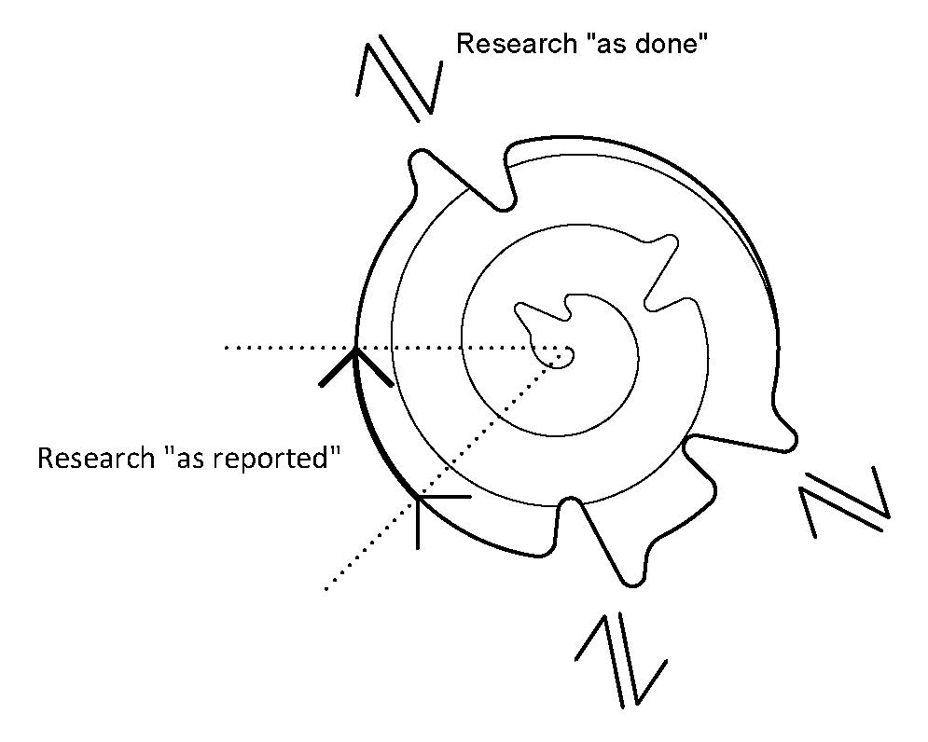
Figure 7: Our understanding of an academic research journey as analogous to the structural coupling of an autopoietic system.
- The post-rationalization often undertaken when reporting design and architectural research has a long-standing tradition. It benefits academic discourse and researchers across fields by presenting stable outcomes that are repeatable and unambiguous (“stable in interpretation,” Glanville 1999: 81), allowing researchers not only to express new knowledge in standardized formats but also to ensure that their findings are understandable and consumable by their peers. Forms of post-rationalization in design and architectural research are often evident in the way methodologies, theoretical frameworks, and narratives are presented. Methodologies, for example, are typically portrayed as systematic and deliberate, despite the inherently messy and iterative nature of the research process itself. Similarly, theoretical frameworks are often applied retroactively, offering a sense of coherence and structure to insights that may have emerged unexpectedly during the inquiry. Moreover, narratives documenting the research journey tend to reframe non-linear, exploratory processes into orderly, logical accounts, thereby conveying an impression of linear progression and intentional design. This clarity in reporting research allows experimental and other results to be tested, confirmed, or refuted by others.
- However, by striving for an “accurate language of description” (Royal Society of London, quoted in Forty 2000: 76), we researchers reporting research overlook our own role as observers within the observed system. This omission leads to a misleading portrayal of the research process. It neglects the subjective experiences and insights of the researcher, including the acknowledgment of deviations arising from the acquisition of new and unexpected insights or failures encountered along the path of inquiry. By often doing so, we end up with reported research that not only neglects the cybernetic principle of learning from errors – a process that Glanville (2014: 63–65) views as both inevitable and desirable – but also overlooks the essence of the constructivist approach that is so integral to the process of doing research. Despite our best efforts to faithfully convey the research journey through the exemplification of the first author’s PhD crises in this study, the nuances, serendipitous discoveries, and often chaotic nature of the research process inevitably lose some of their essences when translated into written form. This highlights the importance of acknowledging the open-ended nature of honest inquiry, recognizing that any written account provides an inherently partial portrayal of the dynamic and interactive process involved in academic research.
- However, this approach is often constrained by the practical, structural, and cultural demands of academic research. For example, most competitive research funding and proposal systems require the clear articulation of goals, methodologies, and anticipated outcomes in advance, with success frequently evaluated against predefined metrics and deliverables. Furthermore, academic publishing tends to prioritize coherence, completeness, and conclusiveness in research reporting, often regarding open-endedness as a limitation. Navigating these challenges necessitates careful balancing, advocating for greater flexibility within established frameworks, and reconsidering how research proposals, evaluations, and outputs are designed to better accommodate the inherently dynamic and exploratory nature of inquiry.
- We hope that the exemplification presented in this study will benefit researchers in general and early-career architectural researchers in particular. The latter, shaped by their architectural studio education and practice – where emphasis is placed on the similarities across all forms of open-ended inquiry – and influenced by a superficial interpretation of formal research reports that overlook critical discourses within the philosophy of science, may be misled into believing that good research is based entirely on rational and linear processes of inquiry. While we can only strive for honesty in reporting how new insights emerged and making sense of them through post-rationalization, it is crucial not to lose the richness of acting on unclear new insights that may diverge from the planned trajectory. It is this “creative freedom” (Hohl 2018: 250) that allows for new connections, experiences, and discoveries. By showcasing a faithful account of a research project “as done,” we aim not only to demonstrate the mechanics of conducting research and illustrate sources of unpredictability but also to reassure early-career researchers that losing a sense of orientation during the process of doing research is common, acknowledged, and even desirable. Nevertheless, it is important to recognize that losing one’s sense of orientation while conducting research does not inherently indicate that the research is being conducted competently.

Acknowledgments
We would like to express our gratitude to the organizational committee of the 60th-anniversary meeting of the American Society for Cybernetics, from which this article emerges. We are particularly indebted to Claudia Westermann for her efforts in fostering an excellent conversational atmosphere throughout the conference. This environment facilitated valuable insights from our peers that significantly contributed to the development of this proposal. To name but a few: Andrei Cretu, Ben Sweeting, Daniel Rosenberg, Mateus van Stralen, Jose dos Santos Cabral Filho, and Dulmini Perera. Additionally, we acknowledge the support of our institutions, the Manchester School of Architecture and the Southern University of Science and Technology, for granting us the time to attend and participate in the conference.

Funding
The PhD project discussed in this article was funded by the XJTLU Research Development Fund under project code RDF-17-01-57.

Competing interests
The authors declare that they have no competing interests.

References
Alvesson M. & Sandberg J. (2021) Re-imagining the research process: Conventional and alternative metaphors. Sage, London.
Aufrecht M. G. (2010) Values in science: The distinction between the context of discovery and the context of justification. PhD thesis, University of Washington.
Barthes R. (1977) Image, music, text. Fontana Press, London.
Barthes R. (1989) The rustle of language. University of California Press, Berkeley CA.
Bunnell P. & Riegler A. (2022) A plurality of perspectives: Maturana’s impact on science and philosophy. Constructivist Foundations 18(1): 1–4. https://constructivist.info/18/1/001
Collins P. (1998) Changing ideals in modern architecture 1750–1950. McGill-Queen’s University Press, Montreal.
Dent E. B. & Umpleby S. A. (1998) Underlying assumptions of several traditions in system theory and cybernetics. In: Trappl R. (ed.) Cybernetics and Systems ‘98. Austrian Society for Cybernetic Studies, Vienna: 515–518.
Feyerabend P. K. (1958) An attempt at a realistic interpretation of experience. In: Proceedings of the Aristotelian Society 58: 143–170.
Foerster H. von (2003) Cybernetics of cybernetics. In: Foerster H. (ed.) Understanding understanding: Essays on cybernetics and cognition. Springer, New York NY: 283–286. https://cepa.info/9150
Foerster H. von & Pörksen B. (1998) Wahrheit ist die Erfindung eines Lügners [Truth is a liar’s invention]. Carl Auer Systeme Verlag, Heidelberg.
Forty A. (1999) “Spatial mechanics”: Scientific metaphors in architecture. In: Galison P. & Thomson E. (eds.) The architecture of science. MIT Press, Cambridge MA: 213–233.
Forty A. (2000) Words and buildings: A vocabulary of modern architecture. Thames and Hudson, New York NY.
Gill R. (2000) Discourse analysis. In: Bauer M. W. & Gaskell G. (eds.) Qualitative researching with text image and sound: A practical handbook. Sage, London: 172–190.
Glanville R. (1999) Researching design and designing research. Design Issues 15(2): 80–91. https://cepa.info/9201
Glanville R. (2012) Second order cybernetics. In: Glanville R. (ed.) The black b∞x. Vol 1: Cybernetic circles. Echoraum, Vienna: 175–207. https://cepa.info/2695
Glanville R. (2014) Acting to understand and understanding to act. Kybernetes 43(9/10): 1293–1300. https://cepa.info/3905
Hohl M. (2018) Rigor in research, honesty and values. In: Riegler A., Müller K. H. & Umpleby S. A. (eds.) New horizons for second-order cybernetics. World Scientific, Hackensack NJ: 249–250.
Johnson P. (1994) The theory of architecture: Concepts, themes and practices. John Wiley & Sons, New York NY.
Kantorovic A. (1993) Scientific discovery: Logic and tinkering. State University of New York Press, Albany NY.
Knorr-Cetina K. (1999) Epistemic cultures: How the sciences make knowledge. Harvard University Press, Cambridge MA.
Kostof S. (1991) The city shaped: Urban patterns and meanings through history. Bulfinch Press, New York NY.
Kuhn T. (1970) Reflections on my critics. In: Lakatos I. & Musgrave A. (eds.) Criticism and the growth of knowledge: Proceedings of the International Colloquium in the Philosophy of Science. Cambridge University Press, London: 231–278.
Kuhn T. (1996) The structure of scientific revolutions. Third edition. University of Chicago Press, Chicago IL.
Lakatos I. (1970) History of science and its rational reconstructions. In: Proceedings of the Biennial Meeting of the Philosophy of Science Association, 1970. Springer, Boston: 91–136.
Latour B. & Woolgar S. (1986) Laboratory life: The construction of scientific facts. Princeton University Press, Princeton NJ.
Linder M. (1992) Architectural theory is not discipline. In: J. Whiteman J. Kipnis & R. Burdett (eds.) Strategies of architectural thinking. MIT Press, Massachusetts: 166–179.
Luhmann N. (1982) The differentiation of society. Columbia University Press, New York NY.
Lynch K. (1981) A theory of good city form. MIT Press, Cambridge MA.
Maturana H. R. (1970) The neurophysiology of cognition. In: Garvin P. (ed.) Cognition: A multiple view. Spartan Books, New York NY: 3–24. https://cepa.info/536
Maturana H. R. (1975) The organization of the living: A theory of the living organization. International Journal of Man-Machine Studies 7(3): 313–332. https://cepa.info/547
Maturana H. R., Uribe R. & Frenk S. (1968) A biological theory of relativistic colour coding in the primate retina: A discussion of nervous system closure with reference to certain visual effects. Archivos de Biología y Medicina Experimentales (Santiago) 1(0): 1–30. https://cepa.info/534
Maturana H. R. & Varela F. J. (1980) Autopoiesis and cognition: The realization of the living. D. Reidel, Dordrecht.
Medawar P. (1964) Is the scientific paper fraudulent? Yes; it misrepresents scientific thought. Saturday Review Aug. 1: 42–43.
Mingers J. (1995) Self-producing systems: Implications and applications of autopoiesis. Plenum Press, New York NY.
Montgomery S. L. (1996) The scientific voice. Guildford Press, New York NY.
Morris C. W. (1946) Science and discourse. Synthese 5(7/8): 296–308.
Ostwald M. (1999) Architectural theory formation through appropriation. Architectural Theory Review 4(2): 52–70.
Otto F. (1995) IL 35 pneu and bone. Institute of Lightweight Structures, Stuttgart.
Pask G. (1975) Conversation, cognition and learning: A cybernetic theory and methodology. Elsevier, Amsterdam.
Polanyi M. (1974) Personal knowledge: Towards a post-critical philosophy. University of Chicago Press, Chicago.
Popper K. R. (1934) Logik der Forschung. J. C. B. Mohr, Tübingen.
Popper K. R. (1959) The logic of scientific discovery. Basic Books, New York NY.
Popper K. R. (2000) The bucket and the searchlight: Two theories of knowledge. In: Keller D. R. (ed.) The philosophy of ecology: From science to synthesis. University of Georgia Press, Athens GA: 141–146. Originally published in 1972.
Potter J. & Wetherell M. (1987) Discourse and social psychology: Beyond attitudes and behaviour. Sage, London.
Pérez-Gómez A. (1983) Architecture and the crisis of modern science. MIT Press, Cambridge MA.
Pólya G. (1945) How to solve it. Princeton University Press, New York NY.
Ravetz J. R. (1973) Scientific knowledge and its social problems. Penguin, Harmondsworth.
Reichenbach H. (1938) Experience and prediction. University of Chicago Press, Chicago IL.
Salmon W. C. (1970) Bayes’s Theorem and the history of science. In: Roger H. S. (ed.) Historical and philosophical perspectives of science. University of Minnesota Press, Minneapolis MN: 68–86.
Sánchez Sotés G. (2024) The appropriation of autopoiesis in architecture. PhD thesis, University of Liverpool. https://livrepository.liverpool.ac.uk/id/eprint/3179091
Sánchez Sotés G., Fischer T. & Herr C. M. (2025) A method for examining the merits of theory appropriation in architecture. In: Han J., Lombardi D. & Cece A. (eds.) Advances in the Integration of Technology and the Built Environment: Select Proceeding of Architecture Across Boundaries 2024. Springer, Suzhou. Forthcoming.
Sánchez Sotés G., Herr C. M. & Fischer T. (2022) What to make of the appropriation of autopoiesis in architecture? In: May C. (ed.) Proceedings of relating systems thinking and design. Systemic Design Association, Oslo: 1–12. https://openresearch.ocadu.ca/id/eprint/4556
Schön D. A. (1983) The reflective practitioner: How professionals think in action. Basic Books, New York NY.
Schön D. A. (1987) Educating the reflective practitioner. Presentation to the 1987 Meeting of the American Educational Research Association. Washington DC. https://educ.queensu.ca/~ar/schon87.htm
Schumacher P. (2011) The autopoiesis of architecture. Volume I: A new framework for architecture. Wiley, Chichester.
Schumacher P. (2012) The autopoiesis of architecture. Volume II: A new agenda for architecture. Wiley, Chichester.
Scott B. (2021) Cybernetics for the social sciences. Brill Academy, Leiden.
Scruton R. (1983) The aesthetic understanding. Methuen, London.
Sokal A. & Bricmont J. (2003) Intellectual impostures: Postmodern philosophers’ abuse of science. Profile Books, London.
Steadman P. (2008) The evolution of designs: Biological analogy in architecture and the applied arts. Routledge, New York NY.
Varela F. J. (2018) Autopoiesis: Orígenes de una idea [Autopoiesis: Origins of an idea]. Universidad de Valparaíso, Valparaíso.
Varela F. J., Maturana H. R. & Uribe R. (1974) Autopoiesis: The organization of living systems, its characterization and a model. BioSystems 5(4): 187–196. https://cepa.info/546
Verebes T. (2014) Masterplanning the adaptive city: Computational urbanism in the twenty-first century. Routledge, New York NY.
Weizenbaum A. (1976) Computer power and human reason. W. H. Freeman and Company, New York NY.

The authors
Guillermo Sánchez Sotés is a Madrid-based chartered architect and a lecturer at the Manchester School of Architecture. He holds a PhD from the University of Liverpool (based at Xi’an Jiaotong-Liverpool University, China), in which he investigated the merits of cross-disciplinary appropriations of natural scientific theory in architecture. He has obtained multiple scholarships and granted funds that enabled him to enroll in both research and teaching at different universities while also collaborating with various international architectural firms, such as Izaskun Chinchilla Architects. Guillermo is also the cofounding partner of Chubby Lab design studio, practicing at the intersection of culture, technology, and research across multiple disciplines.
Thomas Fischer, a professor at the School of Design at Southern University of Science and Technology, is a design educator and researcher. He is the leader of the SUSTech School of Design’s Design Cybernetics Group. Before joining SUSTech, he taught interactive systems design as well as industrial and product design at The Hong Kong Polytechnic University for over 10 years and architecture as well as industrial design at Xi’an Jiaotong-Liverpool University for 10 years. He was a visiting academic at National Cheng Kung University and Humboldt University. He holds a PhD in education from the University of Kassel and a PhD in architecture from RMIT University. He is a Fellow of the Design Research Society, a Fellow of the Cybernetics Society, a Certified Talent of the International Academy for Systems and Cybernetic Sciences, and a recipient of the American Society for Cybernetics’ Warren McCulloch Award. His academic research focuses on design computing, design cybernetics, design geometry, and digital media.
Christiane M. Herr is an architectural design researcher and educator focusing on the areas of structural design, cross-disciplinary collaboration, and digitally supported design. She is a professor at the School of Design at Southern University of Science and Technology in Shenzhen, China. Christiane holds a PhD in architecture and design from The University of Hong Kong and a DEng in structural design pedagogy from the University of Kassel. In her recent work, Christiane has focused on structural and material aspects in cross-disciplinary collaborative design processes involving scientists and designers, with special emphasis on the local context of China.
Submitted: 14 August 2024
Revised: 23 November 2024
Revised: 15 January 2025
Accepted: 17 January 2025

Retrieved on 7 May 2023 from https://www.patrikschumacher.com

