Stakeholder Report
Information Environment Formative Evaluation
EDNER+
FE Library Staff
EDNER+ Deliverable WP2.3
October 2004

Contact

Professor Peter Brophy

CERLIM

p.brophy@mmu.ac.uk

Stakeholder Report, FE Library Staff>

Version control
Version | Date of release | Status/Notes
1.0 | July 2004

This document should be cited as:

Brophy P, Markland M, and Hosty L. (2004) EDNER+: Information Environment Formative Evaluation: Stakeholder Report, FE Library Staff. In support of the EDNER+ Project, Deliverable WP2.3 Manchester: CERLIM (Centre for Research in Library & Information Management)

Information Environment Formative Evaluation EDNER+ is a one year project being undertaken by the Centre for Research in Library & Information Management (CERLIM) at the Manchester Metropolitan University and the Centre for Studies in Advanced Learning Technology (CSALT) at Lancaster University. Details of the project’s work and copies of published reports are available at http://www.cerlim.ac.uk/projects/iee/index.php

Acknowledgements

This research could not have been carried out without the cooperation of the librarians who took the time to complete the questionnaire or agreed to be interviewed.

The help and support of Chrissie Mason at the JISC North West RSC also must be acknowledged, and thanks must also be given to her colleagues across the RSCs for their help in disseminating the questionnaire.

Contents

Acknowledgements 1
Contents 2
Executive Summary 3
1. Introduction 6
2. Aims and Objectives 7
2.1 Aim 7
2.2 Objectives 7
3. Method 7
3.1 Literature Review 7
3.2 The Methods Employed 8
4. Literature Review 9
4.1 Structures and relationships with the FE information environment 10
4.2 Resource management within the FE information environment 12
4.3 The incorporation of online resources into teaching and learning within FE 15
5. Results 17
5.1 The structures and relationships within the FE information environment 17
5.2 Resource management within the FE information environment 26
5.3 The incorporation of online resources into teaching and learning within FE 44
6. Analysis and Discussion 53
6.1 The structures and relationships within the FE information environment 53
6.2 Resource management within the FE information environment 55
6.3 The incorporation of online resources into teaching and learning within FE 61
7. Conclusions and Recommendations 64
7.1 Conclusions 64
7.2 Recommendations 66
8. References and Bibliography 68

Executive Summary

This report provides a preliminary picture of FE College librarians and how they experience, perceive and manage their institutional information environments. Alongside other work already carried out on the EDNER Project, it also provides some comparisons and contrasts with their HE counterparts.

The research is based upon three key themes: structures and relationships with the FE information environment; resource management within the FE information environment; and the incorporation of online resources into teaching and learning within FE. The research focussed upon operational level FE librarians and information was collected using online questionnaires and face-to-face interviews.

The key findings and issues that emerged from the research are as follows:

- Staffing levels within FE libraries vary widely and are largely dependent upon the size of the institution, and how dispersed it was across a number of sites. Thus a very centralised College might have fewer library staff than one with provision scattered across several sites.

- The majority of librarians are placed one tier from senior management, but communication between librarians and senior management is generally good.

- The FE librarian undertakes a wide range of both practical and strategic roles. They are often well integrated into Learning and Teaching Units.

- The use of ICT in FE libraries has helped to raise the profile of libraries, and possibly the status of its staff. There is evidence that ICT staff recognise that recently qualified professional library staff have good IT skills and knowledge, as well as the more ‘traditional’ library skills.

- Librarians were generally the decision makers in the selection of online resources, though there is some concern that teaching staff occasionally purchase such materials independently of the Library, therefore leading to the unnecessary duplication of costly resources.

- Librarians were very proactive in encouraging teaching staff to be involved in the selection of online resources, and also to use online resources within their teaching by offering training sessions. However, responses to requests for feedback and offers of training were often low.

- Librarians were also very proactive in communicating with students, and played an important role in encouraging and training students to use online resources.

- The most popular site within the RDN was the VTS. There were conflicting views about the value of the Hubs. Some respondents felt that some of the RDN hubs were too advanced for FE students. Others thought that there was material of value there, especially where the content was targeted at the FE market.

- Infotrac was the most popular subscription service.

- There were many suggestions for subject areas for which it would be useful to have online resources, indicating the need for further development of online resources specifically for the FE sector. The subject areas most frequently suggested were basic skills and vocational subjects.

- Not all colleges have ATHENS in place, but its use is growing. Further growth needs to be actively encouraged and supported.

- FE libraries are often under considerable financial constraints and do not have allocated budgets for electronic resources. Librarians therefore have to decrease spending on books and other materials to purchase electronic resources.

- In those FE colleges providing franchised HE courses, the FE librarians were often denied access rights to their partner HEI’s online resources, and therefore found it difficult to support this student group. This was of particular concern because the students involved often reported a preference for working with the FE library staff rather than their HE counterparts. Licensing agreements should be extended to include libraries at their partner institutions.

- The use of consortia to purchase resources is not common in FE libraries, particularly in smaller institutions. The JISC’s RSCs could help to facilitate the formation of such consortia

- Librarians were very proactive in the promotion of online resources to both students and teaching staff. However, they were concerned that the resources were not being fully utilised.

- Intranets were popular, and the use of VLEs is growing

Introduction

This study is part of Workpackage 2 of the EDNER+ project, and is based upon consultation with a particular group of stakeholders in the JISC IE, namely library staff in Further Education Colleges and Sixth Form Colleges in the North West of England. As such it contributes to an understanding of Key Theme 3 in the EDNER+ Project Plan, "the effects of the IE's strategy and development on the planning and management of institutional information environments (including learning environments and digital libraries) and the relationships between the two".
Previous work on the EDNER project had shed light upon the perceptions of HE Librarians. Parallel projects in EDNER+ are examining those of FE students and FE Senior Managers, so this study helps complete a preliminary picture of FE College librarians and how they experience, perceive and manage their institutional information environments. It also provides some comparisons and contrasts with their HE counterparts.
There are approximately 400 FE institutions in England and, according to the JISC, the sector is approximately three times the size of HE. FE provides an incredibly wide range of courses and qualifications, from level one basic education to postgraduate qualifications, and caters for all ages from fourteen plus.

The report is structured in the following way:
- Section 2 outlines the aims and objectives of the report.
- Section 3 describes and discusses the methodologies employed to conduct the research.
- Section 4 summaries the key findings from the literature.
- Section 5 presents the findings of the research.
- Section 6 is concerned with an analysis and discussion of the findings.
- Section 7 draws conclusions based upon the analysis and presents a series of recommendations.

2. Aims and Objectives

2.1 Aim
To investigate the information environment within Further Education libraries, and the role played by the JISC, with a particular focus upon the emergence of the use of online resources.

2.2 Objectives
- To explore the structures and relationships within the FE information environment.
- To explore resource management within the FE information environment.
- To explore the incorporation of online resources into teaching and learning within FE.

3. Method

3.1 Literature Review
The literature review provides a picture of the state of knowledge about the key themes within the area of the research. The literature review has been grouped into themes that reflect the objectives:

- Structures and relationships
- Resource Management
- Incorporating online resources into teaching and learning

3.2 The Methods Employed
The literature review gave an indication of a number of issues that FE libraries were facing. However, it became clear through extensive literature searching that very little research about FE libraries had been conducted, particularly in terms of how online resources are surfacing within the FE library environment. It was therefore necessary to design a questionnaire which asked specific questions about the use of online resources within FE libraries, but also extended its scope to gauge a wider understanding of libraries within the FE sector.

An online questionnaire was used for a number of reasons. First and foremost, as the questionnaire was aimed at information professionals, it was felt that this would be the most convenient format for them to use. Secondly, submitted responses were automatically fed into a databases, therefore negating the need for time consuming and costly data entry. Thirdly, because the questionnaire was distributed and submitted electronically, there were no printing or postage costs.

Distribution of the questionnaire was facilitated by the thirteen Regional Support Centres, as preliminary research indicated that this would be the best method of contacting operational level librarians within the FE sector. It should be noted that the term ‘librarian’ is used for the purpose of this report to describe staff with a professional library qualification. The questionnaires were distributed through their mailing lists and various websites. This meant that it was not possible to quantify how many people the survey reached, but 90 responses were received. Due to uncertainty about the response rate, the results can only be interpreted as indicative, not conclusive. The responses were analysed using the Statistical Package for the Social Sciences (SPSS).

Interviews were conducted to gain a deeper understanding of the further education information environment. These were held at ten further education institutions within the North West, consisting of seven FE colleges and three sixth form colleges.

There are 63 FE institutions in the North West region. Further Education Colleges provide a range of full-time and part-time vocational courses, as well as more academic and higher education courses. They tend to be community based and offer courses to those aged fourteen upwards. Sixth Form Colleges are further education institutions where the focus tends to be more upon those aged sixteen to nineteen and primarily studying for A-levels (although a small number of community courses is often offered). For the purpose of this report, the term ‘college’ will be used to describe both types of institution.

The colleges were chosen to reflect the range of FE institutions within the North West, and thus varied in terms of the size of the institution and in terms of the social demographics of students. The locations of the institutions were also chosen to reflect different social demographics within the North West, and therefore colleges located in both inner city areas and semi-rural areas, for example, were chosen. The interviews followed a semi-structured, quite informal format, and were based upon the questionnaire, but offered more in-depth observation, and the potential for probing. The interviews taking place on college sites meant that the researcher had the opportunity to view college libraries, intranets and VLE’s, and thus gain a greater feel for the real FE environment.

4. Literature Review

The literature is presented under themes that reflect the objectives of the research.

4.1 Structures and relationships with the FE information environment
College sizes are classed as small (less than 499 to 7,999 students), medium (8,000 to 17,999 students) and large (18,000 plus students) (CILIP 2003). JISC banding is based upon college size as measured by central funding. Research conducted by CILIP (2003) found that library staffing in FE libraries varied greatly. Small colleges’ staffing levels varied from two to twenty five members of staff. Medium colleges employed between two to forty eight staff, and large colleges staffing levels varied from a minimum of seven to a maximum of forty six. Some of these variations in reported staffing levels will reflect differing definitions of the ‘library’.

4.1.2 Librarians’ relationship with senior management
Pinfield (2001, in Currier, et al, 2001) asserted the importance of senior management support to promote the use of ICT within institutions. Goodall (1996) found that communication between library staff and teaching staff and management needed to improve. This communication problem was reflected by the findings of Roberts and Lamb (2000), who found that only four of the librarians who responded to their survey had direct access to senior management, and 46% of respondents had one tier of management between themselves and senior management. Roberts and Lamb also found that although some FE librarians had experienced improved communication with senior management, such as representation on key decision making forums, this was not the case for the majority of respondents, who were not invited to be involved with strategic level college matters.

4.1.3 Librarians’ roles
Jackson (1997, in Currier, et al, 2001) asserted that library staff would need to develop new skills and roles to facilitate resource based learning. This would include greater involvement in user education and training, and the adoption of new skills concerned with teaching and learning, customer care and team work. Currier et al (2001) discuss the idea asserted by a number of authors that the increased use of digital resources within libraries would cause library staff roles to evolve to incorporate tasks such as teaching information retrieval skills, evaluating and maintaining new learning materials and dealing with legal matters. The findings of Roberts and Lamb (2000) support this theory. They found that library services had indeed evolved. For example, user education and staff support for research have become significant areas of library service provision. They also discussed their finding that services had been extended despite decreases in levels of library staff per student.

CILIP (2003) found that the role of the FE librarian was very varied. For example, 99% of respondents dealt with budget management, 97% dealt with curriculum liaison, 92% dealt with stock selection, 54% were involved with web page development, and 38% undertook shelving duties.

4.1.4 The status of FE librarians
Roberts and Lamb (2000) found that senior management’s perception of libraries had improved because of libraries’ provision for HE courses. However, CILIP (2003) found that libraries’ involvement with HE had not improved the status of librarians. Only 6.5% of survey respondents were classed as senior management, and 67.4% were classed as middle management.

4.1.5 Librarians’ relationships with ICT teams
Unlike HE, FE colleges do not tend to have converged IT and library services, and Roberts and Lamb (2000) found that ICT service provision for different campus libraries within the same institution was variable.

4.1.6 Librarians’ relationships with teaching staff
Goodall (1996) found that relationships between librarians and teaching staff needed to be improved. By 2001 it appeared that there has been some improvement, demonstrated by Pinfield (2001, in Currier, et al, 2001), who asserted that librarians had become more involved in teaching and learning issues. However, Pinfield did acknowledge that relationships still needed further improvement.

4.1.7 Librarians’ relationships with students
Relationships between students and librarians were better than those between librarians and teaching staff, according to Goodall (1996). Goodall attributed these good relations partly to the fact that FE libraries were smaller than their HE counterparts and thus were more flexible and friendly.

4.2 Resource management within the FE information environment

4.2.1 The role of the JISC Regional Support Centre’s
The JISC (2001) describes the role of its Regional Support Centres (RSCs) as being to facilitate communication between the regions and the central committees of JISC, and to disseminate and raise awareness about JISC services. The RSCs were established in 1999, the year the JISC extended its remit to incorporate the FE sector. The JISC Regional Support Centre of the North West (2004) states that it initially provided services related to implementation of JANET, but has now developed its services to support senior management, ILT champions and lecturers, and learning resources and technical staff.

4.2.2 The selection of online resources
CILIP (2003) found that electronic resources in a number of colleges were centrally funded, and felt that this raised the question of the amount of influence that librarians had upon selection on electronic resources. CILIP (2003) also found that 92% of respondents were involved in stock selection, but the report does not specify the level of involvement or the type of stock.

4.2.3 The Resource Discovery Network (RDN)
Williams (2004) describes the RDN as a free, JISC funded service which provides access to websites and Internet resources for use in learning and teaching within the FE and HE communities. The RDN was launched in 1999, and its development is charted on the RDN website (http://www.rdn.ac.uk/about/history/). In 2002 the Virtual Training Suite (VTS) launched specific modules for the FE sector and in 2003 Altis, which had a more vocational emphasis than the other hubs, was launched.
4.2.4 Subscription services
In 2001 the JISC stated its intent to negotiate national agreements for online resources and datasets for the FE sector. The JISC currently offers a number of subscription services that are specifically tailored for FE, and also offers the FE sector the opportunity to subscribe to services which cater for both FE and HE.

However, CILIP (2003) found that not all librarians had awareness of the JISC agreements. Of those respondents who were aware of the agreements, some felt that the resources were too expensive, whilst others felt that they were not appropriate for FE students.

4.2.5 Library Budgets
CILIP (2003) found that library budgets ranged from 0.04% to 3.97% of overall college budgets, with only 7.2% receiving more than 1% of the total college budget. The survey also found that provision for HE courses did not necessarily result in increased library budgets. Roberts and Lamb (2000) found that budgets had decreased significantly since they conducted their previous survey in 1997, despite increased student numbers.

The majority of library budgets were spent on print materials, with 90% of respondents spending at least 75% of budgets on print materials, according to CILIP (2003). However, they stated that this ratio was changing, with a number of respondents indicating that they were intending to increase spending on electronic material within the near future.

4.2.6 The impact of HE provision upon FE libraries
This provision of HE courses at FE colleges has had ramifications for FE libraries. More demands and higher expectations have been placed upon FE libraries. Book stocks and journal subscriptions have increased, opening hours have been extended, and librarians’ roles have changed, mostly in terms of their increased provision of learner support.

CILIP (2003) found that there was no correlation between HE student numbers and library provision. Roberts and Lamb (2000) also found that libraries were struggling to meet the expected standards of the partner HE institution because of resource problems. Despite this, respondents felt that HE provision had a positive impact upon the library service, particularly in terms of librarians’ job satisfaction and in raising the profile of the library service.

4.2.7 Library collaboration and consortia
Pye and Ball (1999) recognised consortia as a method for dealing with decreased budgets and financial restrictions. No literature specifically about library consortia within the FE sector could be found. However, an interesting occurrence that was emerging some years ago, according to the Library and Information Commission (1997), was collaboration between FE and public libraries. The nature of the collaboration is unclear, for example, the literature does not specify whether the collaboration is of a financial nature or just in terms of partnership working, and there is no published evidence to show that this collaboration has been realised on a significant scale (but see also 5.2.8 below)

4.3 The incorporation of online resources into teaching and learning within FE

4.3.1 The promotion of online resources to students
Livesey and Wynne (2001) asserted that students should be taught information skills in order to fully exploit the opportunities of IT. SCONULS’ Big Blue Project (Makin, 2002) resulted in the development of an information skills toolkit, which included a specific toolkit for the post-16 (FE) sector which related to information skills for the Key Skills curriculum for levels one to three. CILIP (2003) found that 98% of respondents were providing library inductions, and 76% were providing information literacy sessions on a continuous basis.

4.3.2 Teachers’ use of online resources
Goodall (1996) recognised that teaching staff might feel threatened by the increased use of technology in libraries and suggested that library staff should provided training sessions in order to alleviate their concerns.

In 2003 the situation seemed to have changed, with Becta (2003) finding ‘73% of teaching staff to be considered competent or advanced in their personal use of IT’ ( Becta, 2003, p. 3). However, the survey also found that ‘in the use of ILT with learners, only 56% of teaching staff are considered competent or advanced’ ( Becta, 2003, p. 3). 48% of colleges were found to use ILT to support learning, with blended learning ( a combination of e-learning and face-to-face teaching and learning methods) only occurring in 18% of colleges. The research concluded that ILT was not yet embedded within teaching and learning, was still only a periphery activity, and that the large expenditure on IT was still not being fully utilised for teaching and learning (Becta, 2003).

The reason for this peripheral use of ILT could be attributed to resistance to change, as suggested by Currier et al (2001). They discuss the reasons behind resistance to change as asserted by Sosabowski, Herson and Lloyd, (1998), and Maier, White and Barnett, (1997). Suggested reasons include lack of technical knowledge, lack of clear IT policies, and negative perceptions associated with moving away from traditional teaching methods.

4.3.3 Library staff training
CILIP (2003) found that 25% of FE libraries have a devolved staff development budget, but they did not incorporate specific questions about the training of library staff into their survey.

The JISC North West RSC states that one of its functions is to support library staff, and they provide various training events for such staff.

4.3.4 The use of VLEs and Intranets within FE
Becta (2003) found that 84% of colleges use their intranet as a learning platform, and 14% of those considered it to be their main learning platform. 59% of colleges had a VLE, with only 5% using it as their main learning platform.

The survey also found that the use of technology to enable students to study more flexibly and at times more suitable to them, for example VLEs and remote access to intranets, was low. CILIP (2003) also found that remote access to intranets and learning resources was limited.

CILIP (2003) also found that library involvement with VLEs was fairly low, with 35% of respondents stating that they had been involved with VLE development.

5. Results

The results from the online questionnaire and interviews with North West FE Librarians are presented within the following key themes:

The structures and relationships within the FE information environment.

Resource management within the FE information environment.

The incorporation of online resources into teaching and learning within FE.

5.1 The structures and relationships within the FE information environment

5.1.1 Staffing Levels
Interviewees were asked to indicate the number of staff within their library. The staffing levels of each college library and the JISC banding of the college (based upon college size as measured by central funding) were:-
Band E:
College C: 38 ‘library staff’ (this includes IT staff)
College B: approximately 15 ‘library staff’ (5 of whom are professional)
College H: 14 ‘library staff’ (12.1 full time equivalent)
College J: 13.9 full time equivalent ‘library staff’ (of whom approximately 4.69 are professional)
Band G:
College A: approximately 25 to 30 ‘library staff’
College H: 14 ‘library staff’ (12.1 full time equivalent)
College D:11 ‘library staff’ (3 of whom are professional)
College F: 9 ‘library staff’ (6.3 full time equivalent, 2.7 of whom are professional)
Band I:
College I: 10 ‘library staff’
College G: 4 ‘library staff’ (one of whom is professional)
Band J:
College E: 2 ‘library staff’ ( 1 of whom is professional)

5.1.2 The Librarian’s place within management structures and their relationships with senior management
Interviewees were asked to describe their place within their institutions’ management structure and the effect this had upon their relationship with senior management:

Libraries were placed within a number of college structures: Student Services, Services, Systems, Estates And Services, Finance And Resources’ Resource Services, Learning Support, Curriculum And Resources’ Student Services
Eight librarians felt that their place within the college structure was satisfactory and their channels of communication with senior management were good. Two colleges were unhappy with their placing in the college structure because they felt their direct senior managers did not understand the role of learning resources. One librarian commented: ‘I need him there, fighting our corner, and I don’t think he is basically….It stops you being able to influence things’. One of the libraries that was unhappy that the relationship with management was located within Students Services. However, another librarian who was also part of Student Services felt that being within that structure was beneficial because ‘We’re managed by student services who go across everybody. So it’s helpful in that respect because it means that we have a foot in every camp’. Only one librarian interviewed was a member of the college senior management team.

5.1.3 Job titles and roles
Interviewees talked about the various tasks they undertook as part of their role, and this is briefly discussed: Their job titles included Divisional Leader Learning Resources, Head of Information and Library Services, Head of Learning Resources, Learning Centre Manager, Learning Centres Co-ordinator, Learning Resource Team Leader, Librarian, Library Manager, Library Services Manager, Site Librarian

All those interviewed had very proactive roles and undertook a number of practical tasks, such as stock selection, training, promotion, etc, alongside undertaking a strategic management role. Unlike HE institutions, no FE library had a staff member in place to undertake specific tasks, such as subject librarian, cataloguer, etc. Tasks that were incorporated into librarians’ roles included responsibility for cross college data protection and freedom of information, high involvement with the college website, management of the college intranet and responsibility for cross college ILT.

During the interviews a number of interviewees discussed the roles of para-professional staff, traditionally called ‘library assistants’. Para-professional staff also had alternative titles to library assistant, for example Learning Resource Facilitators, Learning Support Assistants, Resource Assistants, Information Advisors

5.1.4 The status of FE librarians
Although a question about the status of librarians was not asked at interview, the subject was raised by two librarians. The subject of the profile of the library was also raised by several interviewees:
At one college, librarians discussed how they felt that their status had improved significantly in recent years, because they had a very good relationship with their ICT department and received a lot of respect from them. They felt that this was largely due to the fact that they held a ‘modern’ library qualification, and so had a good ICT grounding, and understood issues such as network management. They had embraced technology to their advantage. One librarian also commented that the status of library assistants had also improved within her institution:
‘..our Library Assistants have gone up to scale four and five. Still, we don’t think that’s enough, we want to raise them even higher, and the way we’re going to do it is by taking on more and more responsibility to this side of the job, the IT side, the VLEs, the intranet, things like that, which you wouldn’t have done ten years ago. If somebody said to you ‘you’re going to be on the project board for setting up the colleges intranet’, you’d have laughed and walked away. But that’s what we’re doing now’.
They are heavily involved with the college IT strategy and have led on a number of high profile IT projects:
‘Everything is starting to revolve around the learning centres and I think that’s a place we need to keep, because then, as you say, our profile will rise, we’ll just keep rising. Because we’ve got more than that string to our bow, it’s not just about knowing the IT and knowing what to do with it, it’s whether you can communicate it to the rest of the world’.

At another college it was felt that the embedding of ICT within the library had made senior management aware of what a valuable resource the library is and believe that their embracing of ICT has been a key factor in widening the profile and status of the library.

Teachers’ awareness of the scope of library services was also discussed, with one librarian stating that teachers who stay with their students during library training sessions often comment upon how they were unaware of the range of services offered by the library. Another librarian mentioned that she had been approached by teachers asking for suggestions for suitable online resources for their students.

5.1.5 Librarians’ relationships with ICT teams
Librarians’ relationships with ICT departments varied, although the majority reported a good working relationship. Some reported close working relationships and good levels of communication. For example, one college stated ‘It’s mainly because we talk to each other. We email and we keep the communication going well’. Some negative responses were given, mainly regarding slow response times, although one librarian attributed this to their ICT team being understaffed. Two librarians reported communication problems with their ICT teams.

5.1.6 Librarians’ relationships’ with teaching staff
Interviewees were asked a number of questions which related to the relationship they held with teaching staff. This included questions about the provision of training to teaching staff, the promotion of resources to teaching staff, and the selection of resources and who was involved with this process.

Interaction between library and teaching staff occurred on a number of levels. A number of those interviewed participated in various management and other strategic level meetings. For example, one librarian stated ‘They’ve also given me a seat on the systems and finance committee which is very useful. It’s good to see how things work, requests come in, they’ll always just relate to funding. But then again a request might change or you need a decision beyond what the teacher can make or support staff. So yeah, there’s good links there in terms of the financial side and with management, because most of the other staff are senior managers and they sit on their own senior management team as well’.

Most colleges also offered training sessions to teaching staff, and used staff development days as an opportunity to promote the library service to teaching staff. One librarian stated ‘we choose developmental time which will best have an impact on academic staff. That, trust me, is hard work. You can create an event, you can do all the right things, and nobody shows up. To begin with, when we launched ourselves as learning resources and e-resources, we created a coffee and croissant morning across all library sites, four sites, we open at eight. Nine to ten on a Monday morning is our meeting slot across the college. Again I’ve argued for the fact that library resources and learning resources all have to meet. So the whole college meets, and we meet, so there’s no centre open until ten. And we figured, why don’t we use that slot and add it till eight, because a lot of staff come in early. So from eight until ten you can go to any of those library services, have a coffee and croissant and look at the resources. And those are very well attended. Then we thought we didn’t get the part time staff, so we did cheese and wine from five until seven. And then we thought during the staff development days we have putting the ‘t’ back into technology, and we had tea and crumpets here. And those are well attended and I might be doing those series of stuff again. And in between we try and find out from staff development or management, when would be an opportune time to get a particular cohor’t.

Another librarian stated ‘We have a day that we usually have in July, which is staff conference, which is the whole college. And I think nearly every year since we’ve had it, I’ve delivered something. First of all it was ‘How to search the Internet’ for dummies. And then it was how to evaluate resources on the Internet, because we’d gone past the dummy bit then. Most people had got on and done something. And last year it was looking at the online databases. And it’s helpful because I actually knew who was coming so I could pick out the ones that I needed to look at. And I give them some things to work through and get them to evaluate what they’d done at the end. So that wasn’t bad… My sessions, I worry about them a lot, because I’m delivering them to people who are teachers, and I’m not. I don’t have a teaching qualification. But the feedback I usually get is good, which encourages me to do another. It encourages the staff development officer to come and get me to do another’. (See also section 5.3.1).

Stock selection was another area where communication took place, with the responsibility very much upon the library staff to approach teachers. One librarian stated ‘The librarians, the one or two that we have, will take responsibility for the whole college, so they’ll actually liase with each individual section manager or quality team. We have self-assessment, it happens in December and February and our librarians and our coordinators in the satellite centres go into the section self-assessment and that is where problems are identified or things are identified that they require’. Another librarian stated ‘What we’ve done is we’ve found electronic resources that can deliver what we think the teaching staff might need. We’ve checked it out with the teaching staff, they’ve said oh yes, and we’ve then bought it. And that seems to work reasonably well. We’ve not so far been asked by any of the teaching staff for electronic resources that we haven’t already been providing’. (See also section 5.2.1).

5.1.7 Librarians’ relationships with students
Interviewees were asked a number of questions which related to the relationship they held with students. This included how they promote resources to students and whether they gathered feedback from students about their use of online resources

The first interaction between librarians and learners at all the colleges where all the interviews were held was through the induction process. All librarians were very proactive in communicating with students, mostly through sessions such as study skills sessions, research skills sessions, and assignment support workshops.

One interviewee commented upon the induction process ‘Last year I took a hard and long look at our induction process, and I decided that we had been doing it very wrong. And we had taken the template from everybody else’s. You drag the student in, you sit them in front of a machine. Click, click, click, click, a thirty slide Powerpoint, tell them everything they need to know, when you’re open, how much a disc costs, student out, goodbye. And all you’ve done is got a great line of thirty clickers. The smart ones just click right ahead and sit there bored. And then you get the staff who don’t even bring there students. Or the staff will bringing their students, drop them off like playgroup and pick them up in forty minutes. So I said ‘no’. What we need to do is rethink. What is our remit. And learning resources remit is to instil the love of learning’.

Another librarian stated ‘Inductions are a bit of a grey area I think, certainly in FE. For full time students, particularly non -HE students in FE, there is a compulsory induction programme usually in the first week of term. But I don’t favour library inductions in the first week of term because I don’t think they’re relevant. So we get virtually every FE student through the week induction programme. What we try to do is talk to the individual tutors through our subject librarians and offer a refresher or something a bit more detailed subsequent to a time when the students have actually got an assignment or some work that they can see how the library is relevant. Because I don’t think the library is relevant in the first week of term for most students’.

The use of study skills sessions and assignment-based workshops were discussed by a number of interviewees. For example, one librarian stated ‘…we do study skills sessions with each group. They come in and actually book sessions with me if they have a specific assignment to do and then I go and look at the resources, see what’s available and target the resources that way to the students’. Another interviewee commented ‘We have an assignment support programme, where we use the online resources to help students to find things for their assignments that they’ve been set’.

Printed material was a method of promotion used by all those interviewed. One librarian stated ‘We do our own guides in bright colours. They have attracted quite a bit of interest. We do the hands on, easy to follow guides, which are lots of screen dumps basically’. Another interviewee stated ‘When we first started to opt in to a lot of the free resources that JISC was giving us we decided that the best thing for us to do was to implement the change event and to give people a sense of security, because people like hard copy as security. We created this [shows researcher the e-resource portfolio]. And we bring these up to date, we were doing it yearly, we’re doing it twice a year because we keep changing our portfolio of e-resources. And what we’ve done is we’ve tried to just do a screen capture so that academic and studentship can look at this and say ‘oh yeah, I might want to go into that’. So basically its our menu, and we keep them by the machines and when we do e-resource skills we bring these out and we let people work through them, which is how we all learnt. It’s one thing to have a Powerpoint, but actually, once you start getting into some of these and find your thread through, you have a reason for using it. So this is how we are starting with our JISC resources. We’ve also dropped in our own resources that we pay for, so again, we’re building up the portfolio so people can see what is actually available here’.

In terms of gathering feedback, this was mostly done using paper-based questionnaires. One librarian stated with regards to their library questionnaire ‘We ask them have they heard of things to find out are they using them. Do they know about them, in the first instance. And that way we can actually judge whether they’ve been, whether it’s sunk in during the induction. So they are asked ‘have you heard of Infotrac?’, and then we judge from there whether we’re actually doing the right job and whether we’re selling it well enough’. Another interviewee stated ‘We have a questionnaire. We scope all of our users so we will send ten copies out to ten different tutor groups in the college and get them to fill them in during the tutor group to make sure that we get them back. Then we do ad hoc scoping where we have questionnaires that we hand out in one session when it’s busy, to get it out to all the users who are in there if they haven’t been scoped. We will then go to our registered adults, community users, so outreach people will be sent them in the post. And ACE people as well, people who do adult community education, and our community users will also be sent them in the post as well. And teaching staff are scoped as well. And then we produce a report based on that’.

One interviewee commented ‘On our annual user survey we do have a question ‘if you use the following online resources, can you rate how good you found them’, or something like that. And it lists each one, so I’ve got feedback in that way. But a lot of them will tick very good and they’ve probably never even used it. And then you do get a lot of comments like ‘didn’t know that existed’, ‘what is that’. And I’m thinking ‘oh god, we really need to promote these better’. (See also section 5.3.1)

5.2 Resource management within the FE information environment

5.2.1 The selection of online resources
Both questionnaire respondents and interviewees were asked about how they found out about new online resources. They were also asked to give an indication of their level of involvement in the selection process of online resources:

Discovery of resources :Questionnaire results:
When asked about discovery of new online resources:
- 92% were approached by the JISC Regional Support Centre
- 81% found information from the JISC website
- 77% were given information at a JISC conference/seminar
- 66% were approached by the JISC
- 61% received recommendations from colleagues within their institution
  - 53% received recommendations from colleagues outside of their institution
- 27% received recommendations from teaching staff
- 22% received recommendations from their affiliate HE institution

Other methods of discovery included:
- Approached by publisher
- Recommended by ILT champion
- Conference attendance, e.g. International Online
- Jiscmail groups
- Own research

Discovery of resources: Interview results:
All those interviewed had high praise for the JISC North West RSC, and stated that communication from them was the most common way of finding out about new online resources.

Librarian’s level of involvement in the selection of online resources

Questionnaire results:
Respondents were asked to indicate their level of involvement in the selection of online resources:

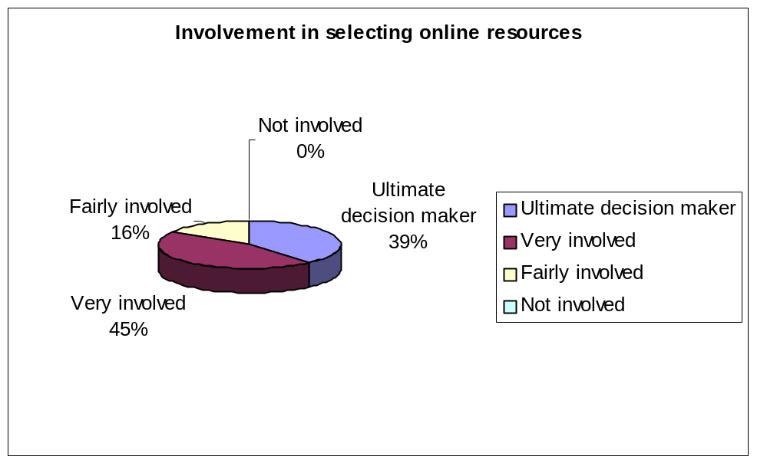

Interview results:
In six colleges the librarians were the sole decision makers in selecting online resources. One librarian discussed how she did try to involve teachers in the selection process, but rarely received responses, and attributed this to teachers’ lack of time rather than apathy. Two librarians felt that teaching staff did not have the knowledge to select online resources, with one librarian stating ‘Most of them haven’t a clue of what to buy’. Another librarian commented in response to the suggestion of teachers selecting resources ‘We would never have anything if that was the case. I think with teaching staff they tend to be quite focussed on their area, it’s difficult for them to see the bigger picture….. Departments don’t even talk to each other very often. So you could end up with two departments buying the same thing if it was relevant to them… So we prefer to control it as a learning resource’.

Librarians initiated the selection of resources but in two colleges consulted with teachers. Another librarian worked closely with the college ILT co-ordinators, who were asked to trial new resources. One librarian discussed how although they selected the majority of online resources, teaching staff purchased their own very specialised material for particular courses.

5.2.2 Librarians’ awareness and use of the RDN
Questionnaire respondents and interviewees were asked to indicate their awareness and use of the RDN hubs:

Questionnaire results:
Respondents were asked to indicate which RDN hubs they were aware of but had not tried:

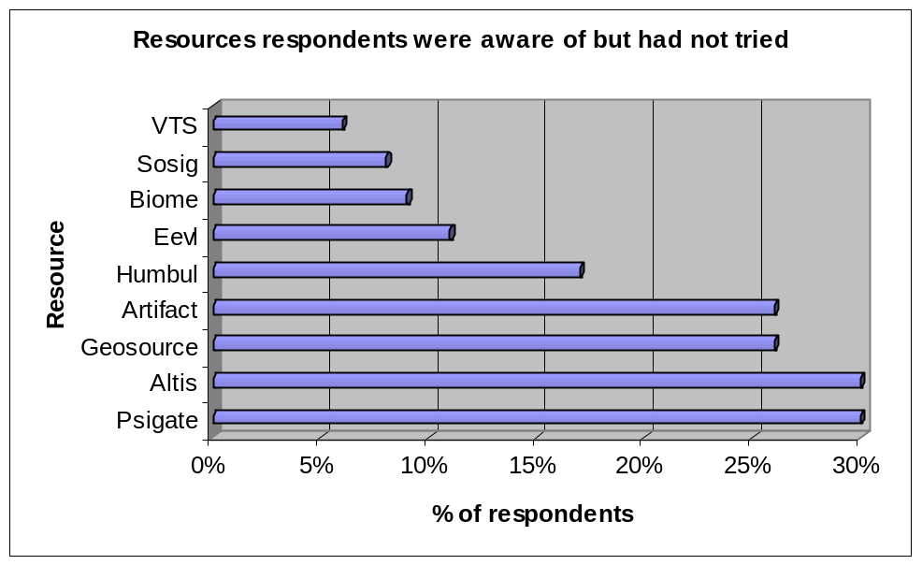

Respondents were asked to indicate which RDN hubs they were not aware of:
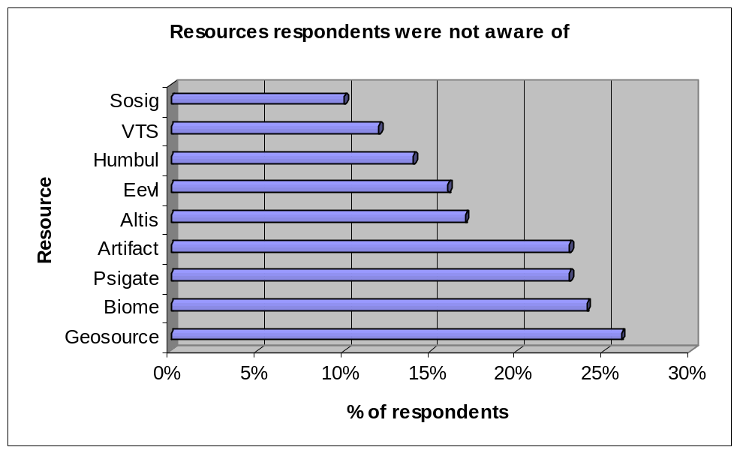

Respondents were asked to indicate which RDN hubs they provided links to:

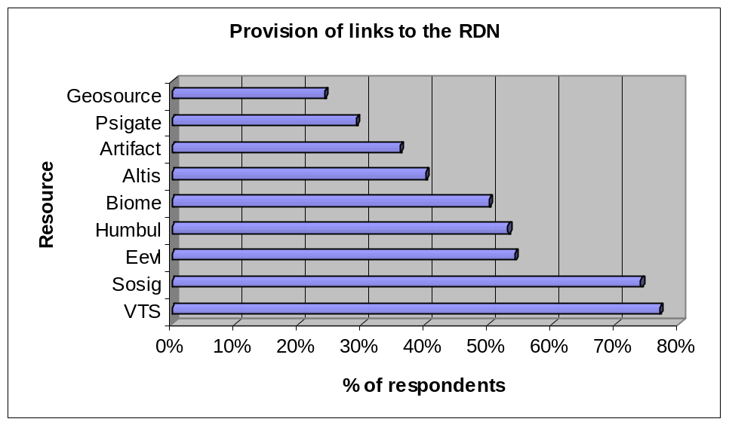

Respondents were asked to indicate which RDN hubs they had tried but had not found to be useful for their students:

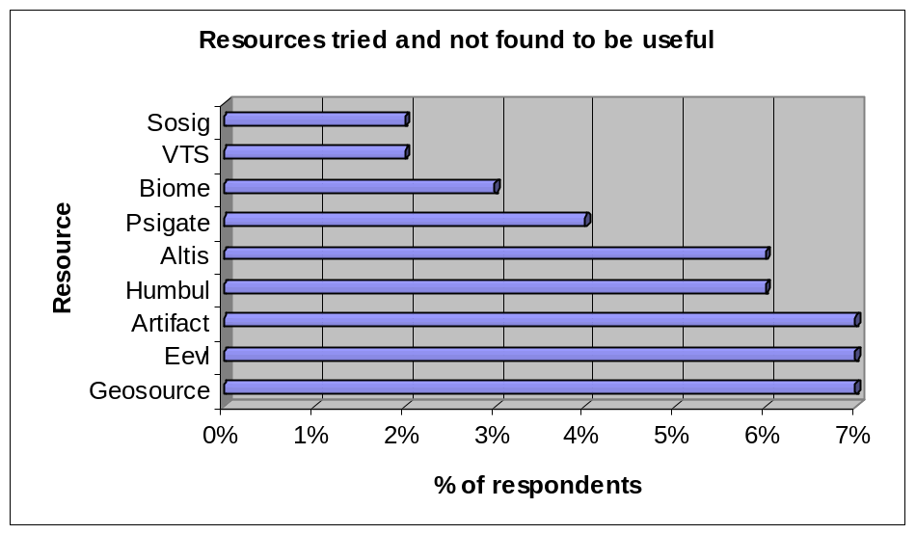

Respondents were asked to indicate which RDN hubs they had not tried specifically because they felt they would not be useful for their students:

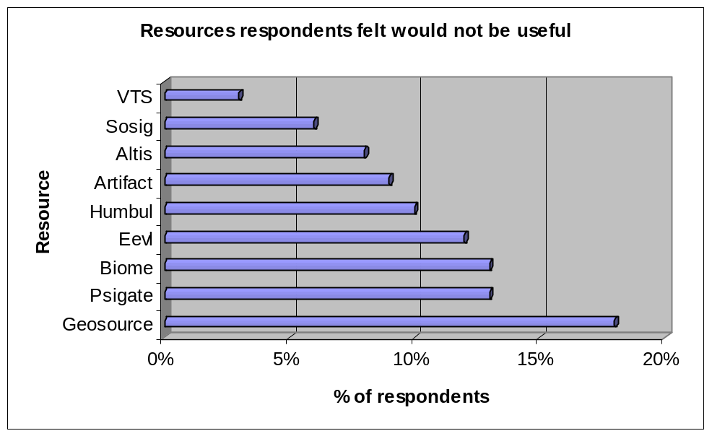

A number of respondents used the further comments section of the questionnaire to make comments about the RDN. These included:
‘VTS too long for students - they think they know it anyway’.
‘BIOME/SOSIG seem too geared to HE level’.
‘Everything on the RDN is useful and fairly easy to use’.

Interview results:
Interviewees were asked to indicate which RDN hubs they provided links to, and were invited to discuss any opinions they had about the hubs:

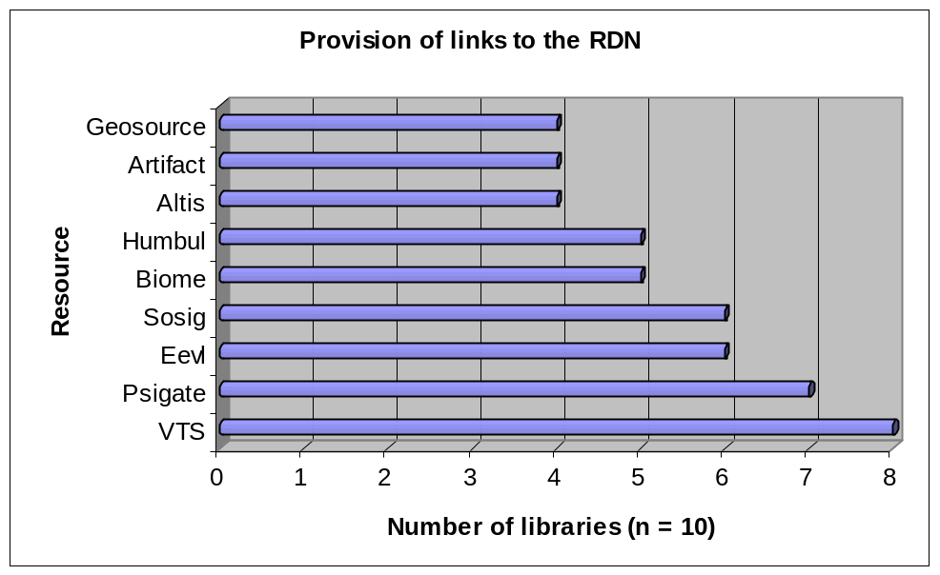

Three colleges linked to all the RDN hubs, and five colleges linked to some of the hubs. Two colleges were unsure what resources were linked to from the intranet, because teaching staff added links themselves.

One librarian commented that she felt EEVL was the best available resource for engineering, and that Altis was exactly the right level for FE. PSIgate received high praise from a librarian at a different institution. One librarian stated that she felt that some of the RDN resources were too advanced for FE, whilst in contrast, another librarian strongly objected to the use of filtering within the RDN FE section because she felt that students should decide what level is suitable for themselves.

5.2.3 Librarians’ awareness and use of subscription services
Questionnaire respondents and interviewees were asked to indicate their use and awareness of a number of subscriptions services that are provided through JISC agreements:

Questionnaire results:
Respondents were asked to indicate which subscription services they were aware of but had not tried:
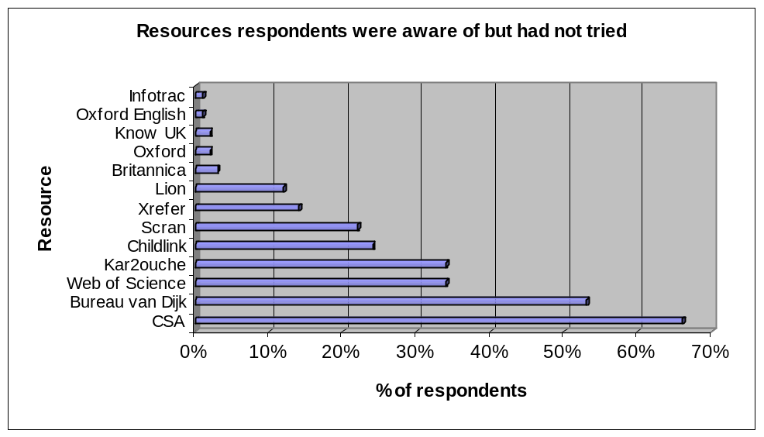
Respondents were asked to indicate which subscription services they were not aware of:
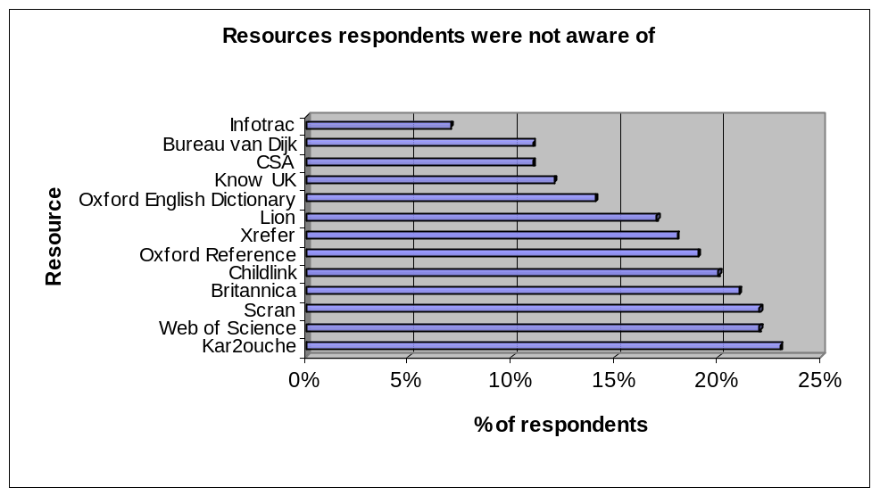
Respondents were asked to indicate which services they subscribed to:
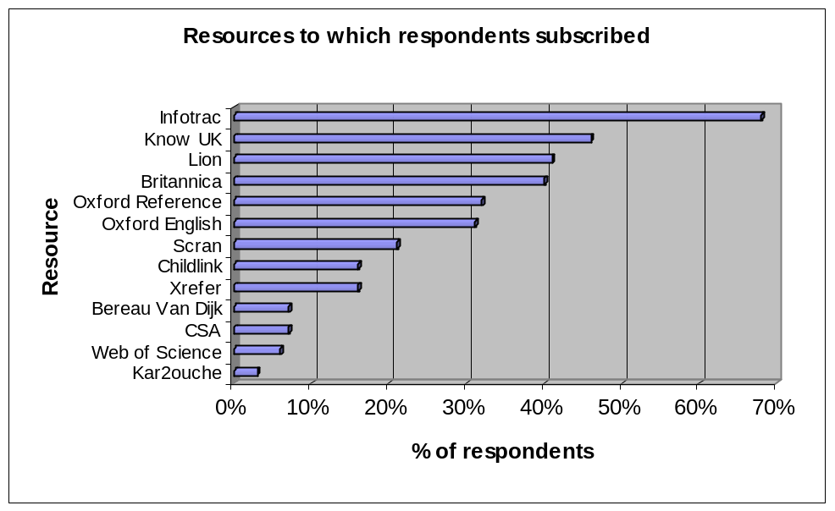

Respondents were asked to indicate which subscription services they had tried but had not found to be useful for their students:

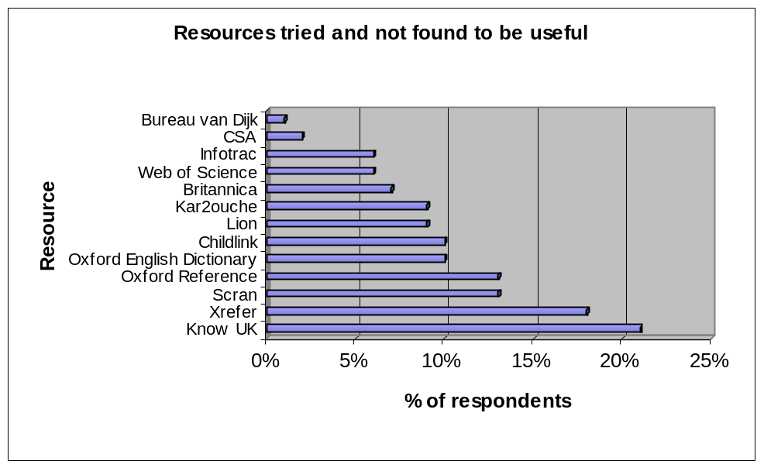

Respondents were asked to indicate which subscription services they had not tried specifically because they felt they would not be useful for their students:

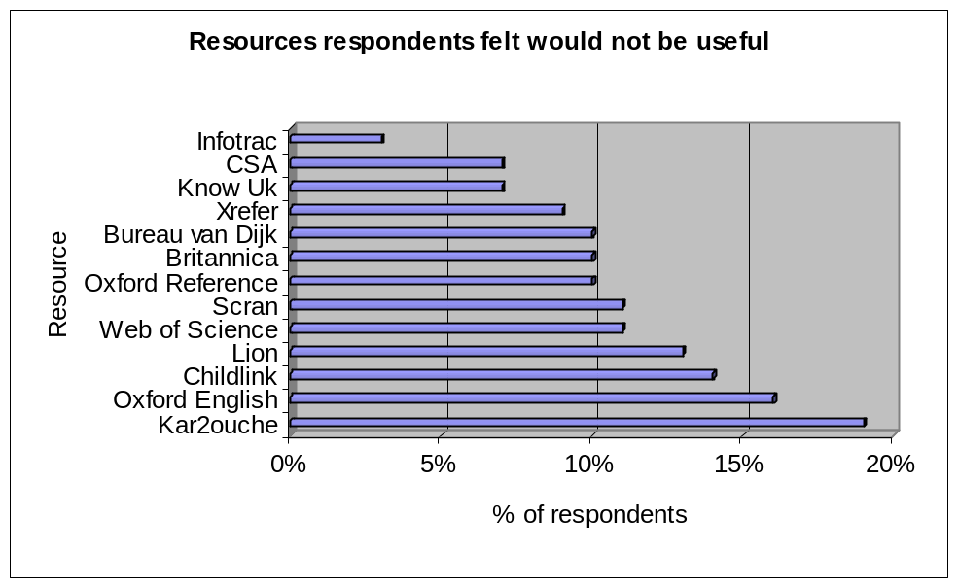

Respondents were asked to indicate which subscription services they felt were too expensive:

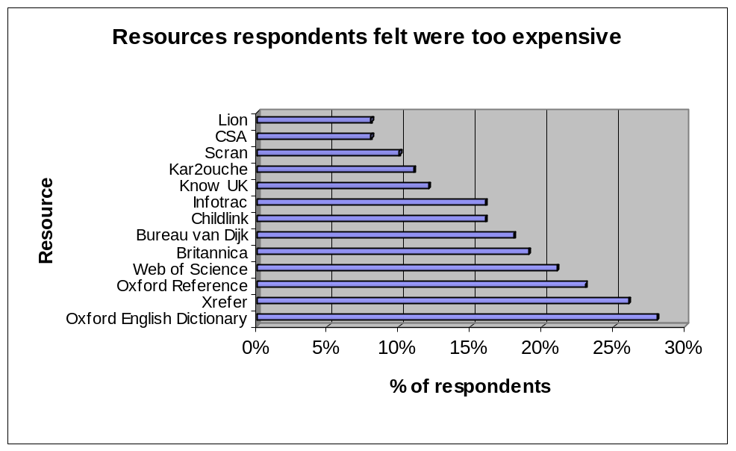

Interview results:
Interviewees were asked to state which services they subscribed to, and were invited to discuss any opinions they had about the services: The colleges subscribed to the resources below. Please note that this list will not be fully comprehensive, as individual teaching departments also purchase subscriptions.
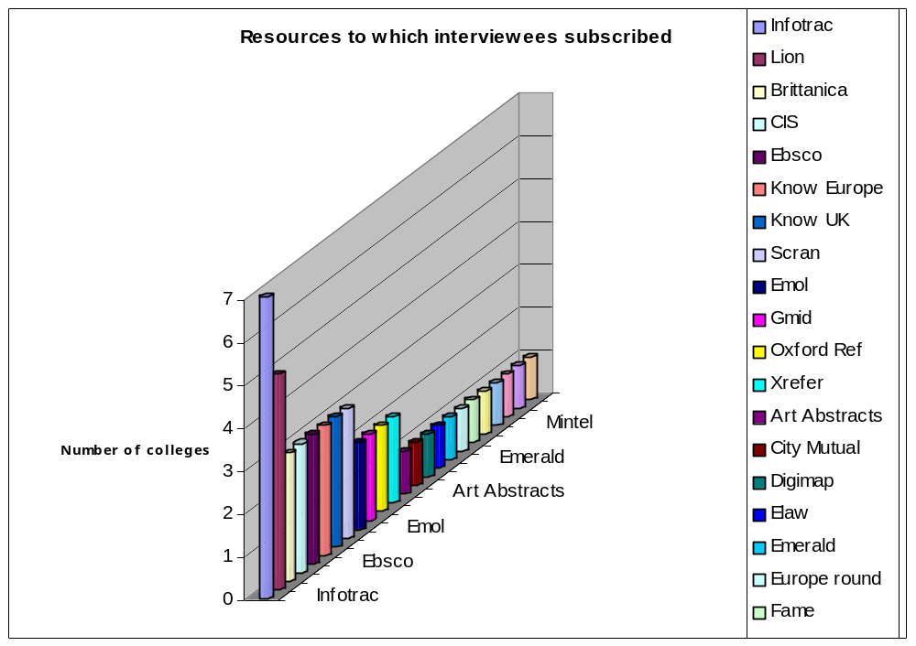

Comments made about subscription services:
‘…..we’re not that fast in the uptake of subscriptions and journals online as we would like to be. A lot of that is mainly down to the fact that number one, finance, and number 2 because it is difficult to promote online resources, more difficult perhaps than something you’ve got physically in your hand’.

‘Infotrac is used widely now across this college. It’s so good because obviously you’ve got such a lot of different levels of availability here. But even level two students are using the newspaper database quite regularly now’.

‘Infotrac is a really good package, for the money, its fantastic. The only snag is that it is American based, so unless you are very specific about what you’re asking it, you get a lot of American results which is not really relevant to a lot of the things that they are doing here’.

‘We’ve got school links (14 year olds). So things like Oxford Reference, they’re just really easy to use and it introduces them to it’.

‘Lion is very widely used here because its specific to A-level and International Baccalaureate’.

5.2.4 Subject areas that FE librarians felt were lacking in online resource provision
Respondents were asked if they felt there was a subject area that was not sufficiently provided for with online resources. This produced the following response

- Adults with learning difficulties
- Animal care
- Art
- Basic skills/ entry level
- Business administration
- Complementary therapies
- Cultural studies
- Education - Cert Ed, teaching assistants, support assistants
- ESOL
- Fashion
- Hairdressing and beauty therapy
- Hospitality
- Information management
- Land-based subject areas
- Languages (for adults)
- Marine engineers, boat builders, water sports students
- Maths GCSE
- Media Studies
  - One stop shop for generic modules in all vocational courses, for example, health and safety.
- Performing arts
- Philosophy
- Photography
- Programming
- Public and Uniformed Services
- Sports science
- Technology – for electricians, plumbers, construction workers etc.
- Theatre design and management
- Theology

Resources designed for specific GCSE and A/AS subjects were also suggested.

5.2.5 Use of ATHENS within FE
Questionnaire results:
Although a specific question about ATHENS was not asked, respondents were asked if students could access online resources remotely. The chart below demonstrates the percentage of respondents whose colleges provided remote access to resources:

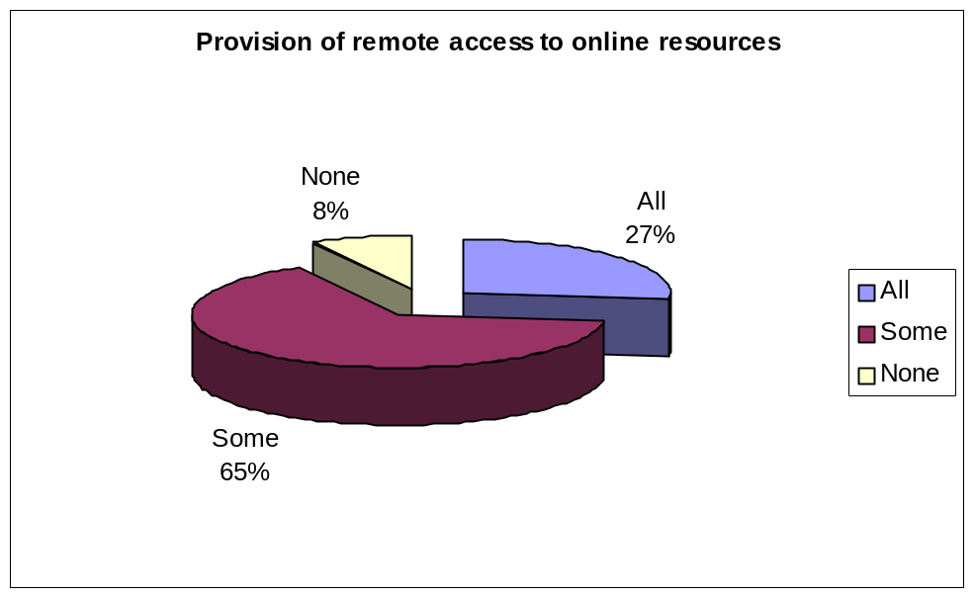

Interview results:
Interviewees were asked whether they had ATHENS in place, and four did so, three were in the process of implementing it, and three did not have it. The use of IP authentication for single user sign-on as a replacement for ATHENS was discussed by two colleges.

One library whose college was currently in the process of implementing ATHENS felt that it would help to increase the use of online resources, stating ‘it will be easier to allow subscriptions because we tend to find that people now are more likely to want it external to the college than internally. So we’re hoping that that way will boost usage and then we can justify having those resources’.

Another librarian felt that use of ATHENS had increased substantially during the past twelve months, and felt that it was particularly useful for their part-time students.

The flexibility that ATHENS offered to students was felt to be very important by one librarian, who stated that ‘…..its very liberating to be able to work with a student and say not only have we got these hard copy resources, if you’re working at home and you have to meet a deadline, we can get you into ATHENS, we can give you 200 resources like that [clicks fingers]’.

5.2.6 Library Budgets
Questionnaire results:
The questionnaire did not ask a question about budgets. However, a number of respondents used the ‘further comments’ section to discuss the issue of budgets.
‘…whilst something like LION is a good resource, we cannot justify spending that amount of money on one subject area. Generic resources like Infotrac and Britannica are better for us’.

‘…can't either get staff interested, or have the budget for everything I would like!’

‘Provision is limited by budget constraints’.

‘We have no extra funding for online resources, so any purchase is at the expense of books/magazines’.

‘Further education often has relatively few students for each subject area and therefore many online resources are far too expensive for FE’.

‘Many general things such as Know UK would be of interest to only a minority of students in a specialist college and even a few hundred pounds expenditure is better spent on buying extra copies of key textbooks’.

‘We are also concerned about the 2/3 year deals provided by JISC, as we may have to end our subscriptions once the reduced rates have finished’.

Interview results:
Interviewees were asked which budget online resources were purchased from, for example library budgets or teaching budgets. They were also asked if they had funding specifically for online resources:

Views about budgets varied considerably, with some colleges feeling that their budgets were quite generous to those who felt it was completely inadequate.

Eight of the colleges had a general library budget, from which electronic resources were purchased. There was no separate e-resources budget. In two colleges, subscriptions came out of the ILT budget. One librarian said the reason for this was because their budget was so small, it would have been impossible to purchase online resources from it.

5.2.7 The impact of HE provision upon FE libraries
Questionnaire responses
Respondents were asked to state their level of agreement with the following statement: “Online resource provision is mostly for students studying higher education courses”:
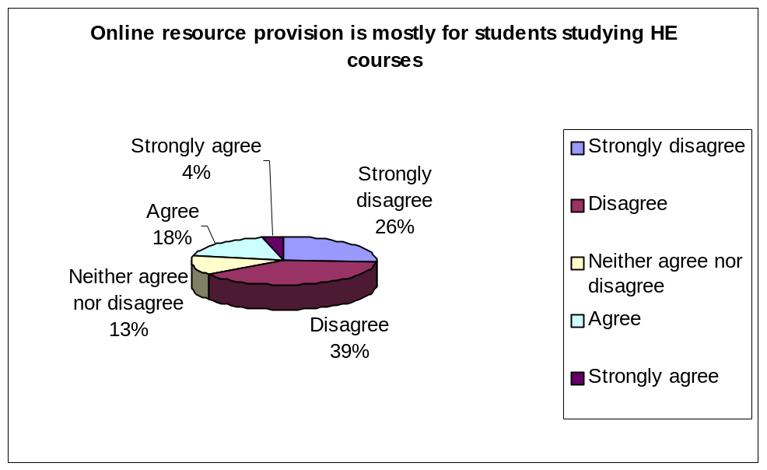

Interview responses:
Interviewees were asked if their college provided HE courses and, if their college did cater for HE, to discuss whether this had any effect upon the library:

Seven institutions (no sixth form colleges) offered HE courses. All librarians had increased their resources as a result of the need to provide for HE students. Four librarians specifically mentioned the fact that they had not received increased budgets to purchase resources for students studying HE courses, and only one librarian had received a budget increase for this purpose. Another mentioned that HE consumed a large amount of their budget.

Two librarians discussed how HE students were reluctant to use their partner HE institution’s library and preferred to use the FE library because it was more supportive. For example, one librarian stated
‘What they don’t do, is use the resources of the host university. For a number of reasons. The first primary reason is that they don’t feel welcome. Two, they don’t feel that it takes into account their timidity of interaction with the resources, and three, they aren’t necessarily staffed by people who understand the journey. So they stay here. So I’m caught, because I need to resource those courses in order to get them validated, which I do, but I’m under the understanding that they have equality of access at the host institution. When they choose not to take up that, I am then left with a resource problem’.

Another librarian discussed how offering HE courses had positive ramifications for their FE students, stating ‘its meant that we do tend to purchase quite a lot of HE related resources, both books, journals and electronic resources. Its also affected things like opening times. We have very long opening times compared to many other FE colleges. And that’s largely down to the high number of HE students we have. The FE students benefit from those extra opening times. The FE students will also benefit from the other resources that we’ve bought’.

An issue that arose a number of times was that for franchise courses, only the course lecturers and students had access to the university’s online resources. The library staff did not have access rights. This was a frustrating issue for FE librarians, as they felt that it impinged on their ability to support the HE students, as they did not know how to use the resources themselves. In the period that the interviews took place however, this situation did seem to be changing, and a number of colleges were in discussions with the HE institutions to obtain access rights.

5.2.8 Library collaboration and consortia
Interviewees were asked to discuss if they were part of any consortia agreements and whether they collaborated with other libraries:

Three colleges were members of a purchasing consortium and one college was considering joining a public library consortium. One of the librarians stated that as a result of joining a consortium they realised they were getting far less of a discount than their HE colleagues with a certain publisher. Having this knowledge meant that they could renegotiate prices.

Two of the librarians said that their colleges were currently in preliminary discussions to develop new community libraries, which would be a joint initiative between the college and the local public library.

Although collaboration in terms of budgets does not seem common within the FE library community, all those interviewed were very active in terms of collaborating with colleagues from other institutions to offer support and share best practice. One librarian stated ‘we have a look around their learning resource centre and that’s how you learn, really, about that works and what doesn’t’.

5.3 The incorporation of online resources into teaching and learning within FE

5.3.1 Promotion of Online resources to students and teaching staff
Promotion of online resources to students
Questionnaire respondents and interviewees were asked to state how they promoted online resources to students:

Questionnaire results:
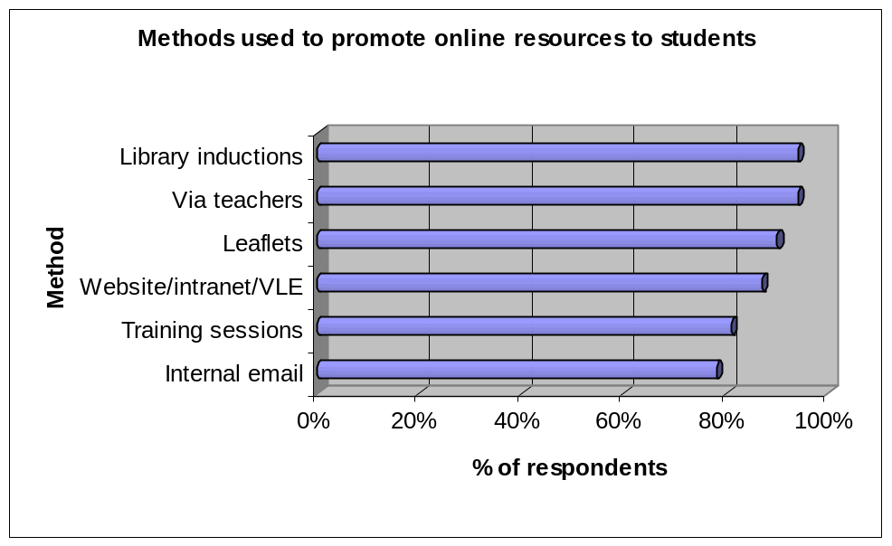

Interview results:
All those interviewed conducted library inductions, although in only three colleges were inductions compulsory. Inductions were regarded as an important tool to encourage students to use the library, and all the librarians interviewed spent a significant amount of time designing inductions to make them effective. One librarian stated ‘if you don’t catch people at the beginning and give them a reason why you think they should be interacting with a resource, a good resource, good people, a good system, then you’ll never recapture it again’. In terms of the effectiveness of inductions, one librarian commented that ‘For an induction to be successful it has to be memorable and quite succinct, because if you overload them with information you can just see their eyes glaze over. So we make sure that we back that up with stuff they can take away and the presentation is on the intranet so they can go back and look at it later on if they want to’.

The use of printed material was a popular method of promotion. This included printed subject-specific e-resource sheets, guidance sheets for individual resources, general library guides, and e-resource portfolios.

Six librarians ran subject specific study/research skills sessions for individual tutor groups. Of those six, three colleges ran assignment-based workshops, which meant that the research session was focussed upon the students’ first assignment.

Other mechanisms of promoting online resources included the college intranet and verbal promotion when helping with enquiries. Three librarians stated that they felt the best way to promote resources was through teaching staff. One library had recently employed a full time learning advisor, whose main remit was to promote resources, particularly online resources, to students.

Promotion of online resources to teaching staff

Questionnaire respondents and interviewees were asked to state how they promoted online resources to teaching staff:

Questionnaire results:
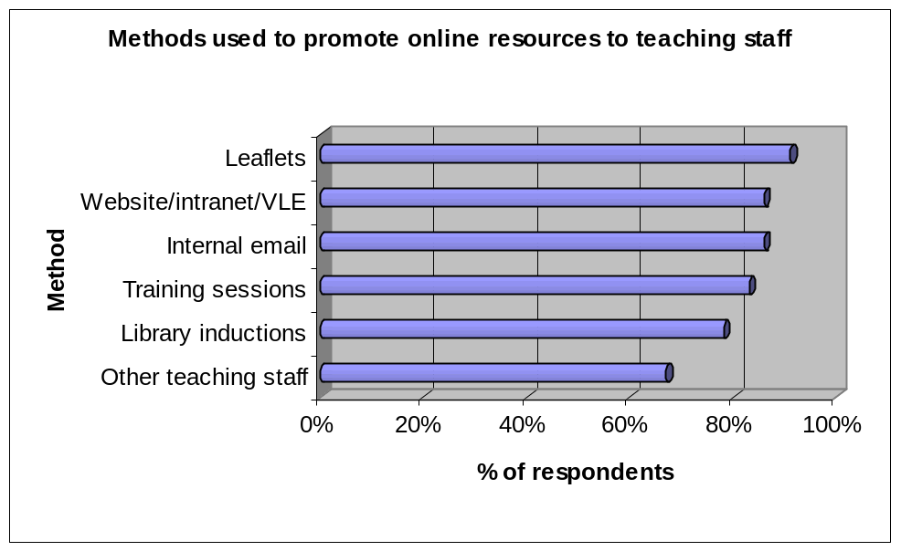

Interview results:
All libraries offered training sessions for teaching staff, and two colleges additionally offered informal drop-in sessions. Librarians also kept teaching staff informed about new resources by email and meetings, and one college gave all new teaching staff an induction pack which lists resources that would be useful for their subject. Three librarians offered basic IT sessions for teaching staff, such as how to use email, Internet search skills, how to use a USB memory pen, etc. One college commented: ‘I think as well there’s a little bit of a fear of appearing not to know what they feel they ought to know, so that staff won’t go to the one on one sessions that the Learning and Teaching Champions have organised, but they’re quite happy to come and sit down here with our IT support people and let them take them through it because it appears to be a less formal approach’.

The importance of training teaching staff as a method for encouraging students to use online resources was discussed by one librarian, who stated ‘They will disseminate for us. They will be able to go into class and say ‘we’ve got this new product’. Where I can’t get that access, they will’.

5.3.2 Training of library staff
Questionnaire respondents and interviewees were asked whether they had received training on how to use online resources and whether they cascaded training to other members of library staff:

Questionnaire results:
81% of respondents had received training on how to use online resources, and 94% cascaded training to other library staff.

Interview results:
Six librarians had received training on how to use some of their online resources, either directly from the publisher of a subscription that they had purchased or at a training event organised by the JISC. Two librarians had also attended training sessions at their partner HE institution. Librarians used staff development days to cascade training to other library staff. The majority of librarians discussed how the onus was very much upon themselves to learn how to use the resources and cascade down to para-professional staff. Four librarians discussed how they found it difficult to attend training events because of time and staffing constraints, and that it would be useful if in-house training could be provided. One librarian also felt that training events were too London-centric, stating ‘We are using the digital resource for images. We don’t use them to the best and their training hasn’t been North West. Again, they drag you down to London. And I have this real angst about being dragged down to London for training’.
One librarian who had not received any training felt that training would be particularly useful for library assistants, so that they could promote online resources to students, stating ‘That may be part of the problem in marketing the resources is that we’re not confident enough to use them ourselves so it’s difficult then to sell it to somebody else’.

5.3.3 Students’ and teachers’ use and awareness of online resources
Questionnaire respondents and interviewees were asked if they gathered feedback from students and teaching staff about the use of online resources:

Questionnaire results:
79% of respondents gathered feedback from students and teachers about the usefulness of online resources.

Interview results:
Seven librarians stated they gathered feedback from students using a library questionnaire, with three of those containing specific questions about online resources. Two libraries had a section within the general college students questionnaire, and one college had no formal mechanism for gathering feedback. One librarian who conducted assignment based workshops approached teaching staff for feedback about the effectiveness of the workshops, asking whether teachers felt that student results were improving as a consequence of the workshops.

Students use and awareness of online resources
Questionnaire respondents and interviewees were asked to indicate how useful they felt students found online resources:

Questionnaire results:
Of those respondents who gathered feedback from students, 26% felt that students found online resources very useful, and 46% felt that students found them fairly useful. 7% felt that students found online resources neither useful nor not useful, 1% felt that students did not find them useful, and 21% answered ‘not applicable’.

A number of respondents added comments about student use of online resources in the further comments section, including:

‘Students seem much more open [than teachers] to the concept of online services, already being keen Internet browsers’.

‘Still concerned about under use of very expensive resources. Need to do much more promotion with both staff and students’.

‘If anyone can come up with a way of convincing FE students that Ask Jeeves is not the greatest thing since sliced bread I would love to know!!’.

Interview results:
All those interviewed felt that online resources were not being fully used. A number of reasons were given for lack of use. Three librarians discussed students’ dependence upon Google, with one librarian stating ‘But they are the Google generation that may go straight past any portals to Google or Ask Jeeves. Which is okay up to a point, as long as they have the discernment to realise that a lot of what they’re looking at is utter garbage. But that’s the worry, they don’t’. Two librarians discussed how it was difficult to promote resources to students because they are not a captive audience, and one librarian was frustrated at teachers’ lack of promotion to students. A number discussed how their College was struggling to increase the use of online resources. Despite actively promoting the resources through training sessions, printed material, etc, student usage was still quite low and librarians were unsure how they could increase use. One librarian had been set a target by senior management of increasing student use of online resources by 30%.

Teachers’ use and awareness of online resources
Questionnaire respondents and interviewees were asked to indicate how useful they felt teaching staff found online resources. Interviewees were also asked to discuss the willingness of teaching staff to incorporate online resources into their teaching methods:

Questionnaire results:
Of those respondents that gathered feedback from teachers, 29% felt that teachers found online resources very useful, and 43% felt that teachers found them fairly useful. 4% felt that teachers found online resources neither useful nor not useful, 2% felt that students did not find them useful, and 21% answered ‘not applicable’.

A number of respondents added comments about teachers’ use of online resources in the further comments section, including:

‘I have been really encouraged that I am now being asked by tutors to give training on other databases apart from Infotrac, which is the best used’.

‘Teachers are very interested and enthused by online resources, but, in my institution, lack the time to tailor them to their needs and/or put links from the VLE’.

Interview results:
All librarians discussed how teachers’ use of online resources was mixed, ranging from those who were very enthusiastic to those who completely refused to use them. The majority of librarians stated that it tended to be the younger members of teaching staff who were more willing to use online resources, whereas older teaching staff tended to be less keen to change their teaching methods. They also discussed how many teaching staff, particular older teachers, were not particularly IT literate.

One librarian had conducted an IT skills audit across her institution and found that a number of staff were struggling with IT, and stated ‘Now the audit has given us ideas about what level of IT some of the section staff have got. So we know why we’re having issues with some of them in bringing the ILT. Because basically, they’re not going to use an online resource if they’re struggling to use email. Or if they’re struggling to access the intranet. So we’re addressing those issues first and then we can go on to the electronic resources’. One librarian discussed how some teaching staff were unwilling to learn new IT skills, and commented ‘There are some people who just don’t want to use any of the new stuff at all. In fact take a delight in telling you that they never look at their emails’.
In contrast, one librarian felt that the majority of teaching staff were very keen to use online resources because they could access them from home. Another librarian commented upon the younger members of teaching staff’s enthusiasm about online resources: ‘A lot of the younger, newly recruited teaching staff are very proactive with it and we’ve done poster for them which they’ve got up in their classrooms, they encourage students to use them. They actually use IT as an integral part of their teaching schedule’.

5.3.4 The use of VLEs and Intranets within FE
Interviewees were asked if their college had an intranet and/or VLE, and whether remote access was available. Questionnaire respondents were not asked a specific question about intranets or VLEs. However, they were asked about remote access to resources.

Questionnaire results:
No specific question was asked about intranets or VLEs. However, 65% of respondents stated that all of their online resources could be accessed remotely, and 27% of respondents stated that some of their online resources could be accessed remotely (See section 5.2.5). The use of intranets and VLEs is also indicated as 87% of respondents stated that they use their website/intranet/VLE to promote online resources to students (See section 5.3.1.1).

Interview results:
Five colleges had VLEs, two colleges were in the process of implementing a VLE, and three colleges did not have a VLE nor were intending to implement one in the near future. In only one college was the librarian heavily involved in the running of the VLE, and they actually played a leading role in its development. One librarian whose college was intending to implement a VLE disclosed that senior management were expecting him to lead the project.

All colleges had an intranet, including two with remote access, and one college was in the process of developing remote access. Librarians played a greater role with intranets than VLEs, often managing the content for their section of the intranet. One librarian had the role of intranet manager within his remit.

6. Analysis and Discussion

6.1 The structures and relationships within the FE information environment

6.1.1 Staffing Levels
The interviews found that the staffing levels in FE libraries varied considerably. Even institutions which were classed within the same JISC banding, which is indicative of a similar college size and budget, had very different staffing levels.

6.1.2 Librarians’ places within management structures and their relationships with senior management
The majority of librarians interviewed in this study were one tier from senior management. However, most respondents reported that access to senior management was not problematic and communication was good.

6.1.3 Job titles and roles
There has been much recent discussion of the changing role of librarians, including their increased involvement with learning and teaching issues, and widening their remit to include dealing with legal matters, and maintaining and evaluating new learning materials. Our interview responses imply that this vision has come into fruition. This is reflected in job titles, such as Learning Centre Manager and also in the description of their everyday duties. All those interviewed had very proactive roles and undertook a number of practical tasks, such as stock selection, training, promotion, etc, alongside undertaking a strategic management role. Other roles within the librarians’ remit included managing data protection and freedom of information across college, substantial involvement with college websites, managing intranets, and responsibility for cross college ILT. The job titles of para-professional staff had also changed from that of traditional Library Assistant to more learning focussed titles such as Learning Resource Facilitators, Learning Support Assistants, Resource Assistants, and Information Advisors.

6.1.4 The status of FE librarians
A number of those interviewed reiterated the view that franchising had raised their library’s profile within their FE institution and particularly with senior management over recent years. In addition, in terms of personal status, interviewees perceived that this too had improved, and they attributed their rise in status to their involvement with ICT. Only one librarian interviewed was a member of senior management team.

6.1.5 Librarians’ relationships with ICT teams
In terms of the relationship between the library, librarians and ICT departments, interview responses varied from excellent to very poor, although the majority felt that they had a good working relationship with ICT. This had been helped by a growing recognition among ICT staff that professionally qualified librarians have a good understanding of ICT. The main criticism of ICT departments was their slow response times to requests for help, but this was attributed to understaffing problems.

6.1.6 Librarians’ relationships with teaching staff
There has been much discussion of the need for improved relationships between librarians, teaching staff and college management in order to strengthen the role of the library within the institution. Our findings imply that the situation has improved, with interaction between library and teaching staff occurring on a number of levels. For example, a number of librarians participated in various management and other strategic level meetings. Stock selection was a significant area where library staff communicated with teaching staff, with the onus very much on library staff approaching tutors for requests. Some respondents did note communication problems with teaching staff, particularly in terms of lack of response to requests for feedback. Library staff were also proactive in providing library and ICT training sessions for tutors.

6.1.7 Librarian’s relationship with students
Supportive learning environments are key to ensuring student retention. It is clear from our findings that libraries are playing a significant role in supporting students. All those interviewed provided library inductions and training sessions to students, and a number were moving towards a more specific learning support role by providing assignment based study skills sessions.

6.2 Resource management within the FE information environment

6.2.1 The selection of online resources
The JISC (2001) stated its Regional Support Centres (RSC’s) should play a key role in raising awareness of JISC services, and both the questionnaire and interview responses indicate that this has been achieved. All those interviewed had high praise for the North West JISC RSC, and 92% of respondents to the questionnaire stated that they had been approached by their RSC. The questionnaire responses also indicated that word of mouth was another important method of dissemination. Interestingly, only 27% of respondents had JISC resources recommended to them by a member of teaching staff within their institution.

The onus for the ‘official’ selection of online resources on behalf of the college was firmly placed upon library staff. However a number of librarians raised the concern that individual teaching departments also purchased online resources solely for their students’ use. These were usually kept on stand alone designated PCs in that department’s area of the college. Librarians stated that they were generally not kept informed by teaching staff about what resources had been purchased outside of the library. This was an area of concern as it was quite possible for unnecessary duplication of purchasing to occur.

In only one college did library staff conduct the role of subject librarian, although this was not their only role. All professional staff had responsibility for a subject area, and undertook the task of subject librarian amongst their other roles. All librarians were proactive in communicating information to teaching staff about new electronic resources on the market, mostly by emailing information about new resources and arranging trials. However, a number of librarians mentioned that feedback was often poor.

6.2.2 Librarians’ use and awareness of the RDN
Use and awareness of the RDN was good, especially considering that these resources were often developed to meet the needs of the HE community alone. Eighty percent of colleges linked to some or all of the RDN Hubs. According to the questionnaire, the most popular sites within the RDN was the VTS followed by Sosig. Those interviewed also mostly linked to the VTS, followed by Psigate. The popularity of the VTS can possibly be attributed to the fact that it has modules specifically designed for FE. Altis received high praise from one interviewee, and stated that it was aimed at the correct level for FE. This could be due to the fact that Altis was launched in 2003, and thus took into account the needs of the FE sector from the start. It is also a vocational subject-based hub, and as the FE sector is a large provider of vocational courses, the content of Altis may be more appropriate for FE than some of the other hubs. Some of those interviewed felt that the levels of some of the RDN sites were too advanced for FE, which suggests that hubs specifically designed for FE need to be developed, or the existing hubs need to be tailored for the FE sector. The low levels of provision of links to various RDN hubs, particularly Geosource, Psigate and Artifact, by questionnaire respondents may be further indication that the needs of the FE sector need to be addressed. However, only a minority of respondents who had tried the hubs had not found them to be useful for their students, which indicates that there is appropriate material there for FE students. The key issues arising from the questionnaire results appear to be lack of awareness of the hubs, or librarians not trying the hubs. For example, 30% of respondents were aware of both Psigate and Altis, but had not tried them, and 26% of respondents were not aware of Geosource. These issues may indicate that the promotion of the RDN to FE librarians needs to be addressed.

6.2.3 Librarians’ use and awareness and subscription services
The JISC (2001) in its Collection and Curriculum Services for Further Education report stated that it was important to build up datasets of relevance to FE. In 2004 the picture seems positive, with all those interviewed subscribing to at least three datasets. The most popular subscription service for both those interviewed and those who responded to the questionnaire was Infotrac, which received high praise on a number of occasions. The majority of those interviewed had purchased Infotrac through the JISC. The Construction Information Service also received very high praise. The results from the online questionnaire demonstrated that although there was fairly high awareness of the majority of the subscription services, most respondents had not tried them. Further investigations into why this was the case, for example lack of relevancy, unavailability of free trials, cost, etc, would be useful. It should also be noted that because of lack of communication between teaching and library staff (as noted in section 6.1.6 ), institutions may have subscriptions that library staff are unaware of. A consequence of this lack of communication could be that resources are duplicated, which, as stated before, has implications for college and library budgets.

6.2.4 Subject areas that FE librarians felt were lacking in online resource provision
The JISC , in its ‘Collection and Curriculum Services for Further Education’ paper stated that it aimed to develop collections more relevant for the FE sector and also stated that ‘The JISC will encourage the inclusion of learning materials at all levels of granularity’.

However, the JISC collections for FE still appear to need considerable development, as the question ‘Are there any groups of students or subject areas for whom it would be useful to have online resources, but for whom there is currently little or no provision?’ provoked a large number of responses. Both respondents to the questionnaire and those interviewed offered a wide range of suggestions, indicating that there are still a considerable number of gaps in the market. The areas most frequently suggested were basic skills and vocational subjects (particularly for basic level plumbing, construction, etc). It should be noted that a number of subject areas were suggested that do already have quite a substantial level of provision. This then raises the question of levels of awareness of resources, and whether resources are being sufficiently and appropriately promoted.

6.2.5 Use of ATHENS within FE
Further Education plays an important role in widening participation. Remote and flexible access to ICT is an important aspect of widening participation, as it enables students to access materials from locations other than their college site. ATHENS access enables access to subscription services from outside the library walls. Four Colleges had Athens in place, three were in the process of implementing it, and three did not have it. There was also mention of using IP authentication for off-campus access rather than ATHENS. For those which did have ATHENS in place, respondents felt that it was incredibly important for their students, particularly for those who needed to work more flexibly, such as part-time students. The majority of respondents to the questionnaire reported that they provided remote access to resources, with 27% reporting that all their online resources were available remotely, and 66% reporting that some were available remotely.

6.2.6 Library Budgets
Our findings showed that library budgets vary considerably and that there are even wide discrepancies in budget provision between colleges of similar size. Some colleges felt that their budgets were quite generous, while others said their budget was completely inadequate. Eight of the colleges had a general library budget, from which electronic resources were purchased, with no separate e-resources budget. Most colleges surveyed spent at least 75% of their library budget on print materials, although a number of respondents indicated that they were going to increase their spending on electronic resources in the near future. In two colleges, subscriptions came out of the ILT budget. One college said the reason for this was because their budget was so small, it would have been impossible to purchase online resources from it. A number of those interviewed mentioned that their budgets had not been increased to include online resources, and stated they would like to purchase more online resources but were unable to because of financial constraints. One librarian said that JISC resources were too expensive, and also felt very strongly about ‘the unfairness of the JISC banding structure’. Concern was also expressed by several of those interviewed about the future of JISC agreements, and how they were going to be able to continue to purchase various subscriptions once JISC agreements ceased.

6.2.7 The impact of HE provision upon FE libraries
It might have been expected that the ramifications of the provision of HE courses upon FE libraries would be a subject for discussion. Interestingly, the impact of HE, particularly in terms of stretching resources, did not arise as a major issue amongst those interviewed. Although librarians whose colleges did offer HE courses had increased their journal and book stocks as a result of HE provision, and often without increased budgets, it did not come across as being a major issue. Interestingly, the main issue that arose was that for franchise courses, the only people from the college who had access to the resources were the lecturing staff and students. The library staff did not have access rights. This was a frustrating issue for librarians, as they felt that it impinged upon their ability to support the HE students, as they did not know how to use the resources themselves. In the period that the interviews took place however, this did seem to be changing, and a number of colleges were in discussions with the franchise universities to obtain access rights for FE college library staff.

6.2.8 Library collaboration and consortia
Only three of those interviewed were members of a purchasing consortia and one college was considering joining a public library consortium. Two of the colleges interviewed were currently in preliminary discussions to develop new community libraries, which would be a joint initiative between the college and the local public library.

Although collaboration in terms of budgets does not seem common within the FE library community, all those interviewed were very active in terms of collaborating with colleagues from other institutions to offer support and share best practice. The finding from the online questionnaire that 53% of respondents found out about online resources from a colleague outside of their institution is demonstrative of the importance of word of mouth amongst the FE library community.

6.3 The incorporation of online resources into teaching and learning within FE

6.3.1 Promotion of online resources to students and teaching staff
Promotion of online resources to students
In recent years, user education had become a major aspect of library service provision, and all those interviewed provided user education, which was a key method of promoting online resources. 94% of respondents to the questionnaire offered library inductions.

Promotion of online resources arose as a significant issue for most of the librarians interviewed, in terms of the fact that they felt they themselves needed guidance on how to do this. The main method of promotion used by both questionnaire and interview respondents, was through the library induction process, although in all but three of the colleges interviewed, inductions were not compulsory.

Subject based study skills sessions for tutor groups were another popular promotion tool, helping to deliver support in a very targeted way. An emerging format of these sessions was assignment-based workshops, which meant that the librarians were demonstrating directly to students how online resources could fulfil an actual study need.

Printed material, such as posters and printed guides, was regarded as another important tool to facilitate promotion, as it was generally felt that students liked to have something physical to grasp.

Three librarians mentioned that they felt the best way to promote resources was though teaching staff. 94% of questionnaire respondents stated that they promoted online resources via teachers, though one college had recently employed a full time learning advisor, whose main remit was to promote resources, particularly online, to students.

Promotion of online resources to teaching staff
Respondents to the questionnaire were very proactive in promoting online resources to teaching staff, the key methods used being leaflets, email, and the website, intranet or VLE. Those interviewed were also very proactive in promoting online resources, by using the same methods as those used by the questionnaire respondents, and also by offering training sessions and informal drop-in sessions, and a number of other methods. However, take-up of training sessions by teaching staff was low.

6.3.2 Training of library staff
Although skills-based training was not discussed during the interviews or as part of the questionnaire, respondents were asked about whether they had received resource-based training. 81% of respondents to the questionnaire had received training on the use of online resources, and 94% cascaded training down to other library staff. Four of those interviewed had not received any training for their online subscriptions, and at one college librarians stated that one reason why resources were not being fully promoted was because the library staff themselves did not feel completely comfortable using them. The general consensus was that the onus was very much upon the professional staff to teach themselves how to use the resources and cascade it down to non- professional staff. A number of those interviewed also discussed how difficult it was to attend training events because of over-stretched staffing levels, and suggested that more regionalised training, and individual training at their institution would be very useful.

6.3.3 Students’ and teachers’ use and awareness of online resources
Feedback
79% of questionnaire respondents gathered feedback from students and teachers about the use of online resources. All institutions interviewed had mechanisms for student feedback, mostly through a questionnaire. Although only two librarians asked specific questions about the use online resources, all those interviewed had an indication of how online resources were being used.

Students use and awareness of online resources
Library staff were very proactive in promoting online resources to students. Unfortunately, this does not appear to be reflected in students’ use of the resources. The general consensus from the interviews was that the resources were not being full utilised. A number of colleges attributed this to problems of promotion, or to reliance upon search engines such as Google. Of those who responded to the questionnaire, 26% felt that students found online resources very useful, and 46% felt students found them fairly useful.

Teachers use and awareness of online resources
All those interviewed stated that the willingness of teachers to use online resources varied from those who were very enthusiastic to those who refused to use them. They attributed lack of willingness to use electronic resources to poor IT skills, and stated that it was mostly older teaching staff who were least keen to adopt new teaching methods. As noted in section 6.3.1.2, teaching staff were reluctant to attend training sessions, and this could again be an indicator of resistance to change (or simply to lack of time). Responses to the online questionnaire showed that only 29% of respondents felt that teachers found online resources very useful, and 43% fairly useful. It must be emphasised, of course that these were librarians’ perceptions of the opinions of teachers, and not the views of teachers themselves.

6.3.4 The use of VLEs and Intranets within FE
The survey found that actual use of VLEs and other electronic materials was low, and suggested that this could be attributed to lack of teachers’ ILT skills. Of those interviewed, five colleges had a VLE, two colleges were in the process of implementing a VLE, and three colleges did not have a VLE or were not intending to implement one in the near future. Only one librarian interviewed played an integral role in the development of his institution’s VLE, and in fact was leading the project.

All librarians interviewed stated that their college had an intranet, with two colleges providing remote access and one college currently in the process of developing remote access.

7. Conclusions and Recommendations

7.1 Conclusions
The aim of this study was to investigate the information environment within Further Education libraries, and the role played by the JISC, with a particular focus upon the emergence of the use of online resources.
Our research based on a national survey, and interviews with librarians in FE Colleges in the North West of England has found that their FE information environment is one which has to cater for a very wide and diverse user profile. The FE college librarian has to support all ages and levels of learners, from those learning basic skills to those undergoing post-graduate professional training. A major constraint upon provision is that FE libraries function on slender financial resources which are often historically based on the acquisition of print materials. There is rarely a separate budget for the provision of online resources and few FE libraries are members of purchasing consortia.
Libraries are typically run by a small cohort of very enthusiastic staff who are dedicated to providing a high level of service and to meeting users’ needs. They are often grouped with other support services, such as learning resource centres, student services, or IT support and librarians often Librarians have multiple roles which extend their ‘traditional’ library skills into other areas.
There is good awareness of the JISC and of the content and services which it provides. Librarians are keen to encourage both students and teaching staff to use online resources, and they actively promote these through induction programmes and skills training sessions targeted at specific learning needs, but their impression is that the actual use of these resources is still fairly low. Despite the fact that they take on the role of trainer, they are not always confident that they are themselves skilled users of online resources. They would like formal training in the use of new online resources, and better advice on how to promote them to tutors and students. The use of ATHENS and VLEs within FE institutions is increasing, and many librarians feel that this will encourage the uptake of online resources. However remote access provision does not seem to be high.
The incidence of FE libraries linking online to the RDN Hubs varies considerably, with the VTS and SOSIG being reported as the most popular sites. There was concern that some of the RDN hubs were not appropriately tailored for FE, which may account for the low incidence of links to some of them. A further barrier to Hub use was that some librarians were simply unaware of them or had not tried them out.

There was evidence that FE colleges are subscribing to JISC funded services, and some of these (principally Infotrac and Lion) have been well received and are highly valued. Again though there is concern that when subsidies are withdrawn it may not be possible to continue the subscription.

7.2 Recommendations
- Librarians are often constrained by their limited budgets, and by the lack of a budget specifically for the purchase and promotion of electronic resources. If the JISC wishes to promote effective use of online resources and services to the FE sector we recommend that it will need to take this constraint fully into account when pricing products.

- There is a desire for resources specifically tailored to the needs of FE students, though balanced by some concern that resources should not be too ‘filtered’. We recommend that the JISC explores this further with both student and tutor users in the FE community, in order to ensure that its products meet the needs of as many FE users as possible.

- There are large areas of the FE curriculum which are apparently not currently supported by online resources. This may be a genuine lack of resource provision, or it may be a lack of awareness of existing provision. We recommend that the JISC investigate this and prioritise areas of particular need.

- The North West RSC has received high praise from this group of librarians. We recommend that the JISC build upon this success and encourage the RSCs to provide further services to FE librarians. They particularly identify a need for further guidance on how to encourage use of online resources among students and tutors alike, and for further training for themselves in the use of specific online products, though it may be that they will require this training to be delivered ‘in house’. A further role for the RSCs which the JISC might like to encourage would be advising FE Colleges on how to form and manage purchasing consortia.

- The use of ATHENS needs to be encouraged, and its implementation supported, particularly within institutions that have slender ICT staffing levels. This would help FE Colleges to move towards the HE model of providing remote access to resources for staff and students. This would be of great benefit to part time and workplace based students, and would help colleges achieve their aim of widening participation.

- Licensing agreements for HE institutions should be extended to include access for library staff at the partner FE college where courses are provided at both institutions.

8. References and Bibliography

AWRE, C. (2003) Portals: enabling discovery for all in higher and further education. VINE, 33 (1), 5-10

BECTA (2003) ILT in Further Education: laying the foundations for e-learning. Becta. Online, WWW page at URL: http://ferl.becta.org.uk/display.cfm?page=568 (version current June 2004)

CILIP (2003) UK Survey of Library and Learning Resource Provision in Further Education Colleges 2003. CILIP. Online, WWW page at URL: http://www.cilip.org.uk/practice/research.html#fecolleges (version current June 2004)

CURRIER, S., Brown, S., and Ekmekioglu, C. (2001) INSPIRAL: INveStigating Portals for Information Resources and Learning. Centre for Digital Library Research and the Centre for Educational Systems, University of Strathclyde. Online, WWW page at URL: http://inspiral.cdlr.strath.ac.uk/documents/documents.html (version current June 2004)

DAVIES, D. (1997) From the further education margins to the higher education centre? Innovation in continuing education. Education and Training, 39 (1), 4-13

ELLIOT, G., and Gamble, J. (2001) Enhancing collaborative provision: implications for HE/FE relationships. Quality Assurance in Education, 9 (4), 184-196.

GIBSON, A., Newton, R., and Dixon, D. (1999) Supporting open and distance learners: practice and policy across further and higher education libraries. Library Review, 48 (5), 219-231

GOODALL, D. (1996) Academic franchising: some pointers for improving practice. Library Management, 17 (4), 4-9

JISC (2001) Collection and Curriculum Services for FE. JISC. Online, WWW page at URL: http://www.jisc.ac.uk/index.cfm?name=dner_developing_fe (version current June 2004)

JISC Regional Support Centre of the North West. Online, WWW page at URL: http://www.rsc-northwest.ac.uk/aboutRSC/ (version current June 2004)

LEADER, G. (2003) Lifelong learning: policy and practice in further education. Education and Training, 45 (7), 361-370

LIBRARY AND INFORMATION COMMISSION (1997) Learning Works: Widening Participation in Further Education (the Kennedy Report): The Response of the Library and Information Commission. Library and Information Commission. Online, WWW page at URL: http://www.mla.gov.uk/information/legacy/lic_pubs/responses/kennedy.html (version current June 2004)

LIVESEY, S., and Wynne, P. (2001) Extending the hybrid library to students on franchised courses: user profile, service implementation issues and management strategies. Library Management, 22 (1), 21-25

MAKIN, L. (2002) ‘Out of the Blue’ – achievements of the Big Blue Project. SCONUL Newsletter, 26, Summer/ Autumn. Online, WWW page at URL: http://www.sconul.ac.uk/pubs_stats/newsletter/26/CH8.pdf (version current June 2004)

OXTOBY, B. (1999) Viewpoint: what will FE colleges be like in 2015? Education and Training, 41 (9), 396-402.

PEARCE, L. (2003) Our students stakeholders: requirements for institutional portals. VINE, 33 (1), 11-16

PYE, J., and Ball, D. (1999) Purchasing consortia: trends and activity in the UK. The Bottom Line: Managing Library Finances, 12 (1), 12-18

ROBERTS, D, H, E., and Lamb, J, A. (2000) Research in the further education library and learning resources centre sector: the Welsh experience. Library Management, 21 (9), 491-500

WILLIAMS, M. (2004) What can the Resource Discovery network offer FE? JISC. Online, WWW page at URL: http://www.jisc.ac.uk/index.cfm?name-rdn_for_fe_news (version current June 2004)

WYNNE, B., and Shergold, C. (2004) Achieving ‘single sign-on’ access. Update, 3 (5), 42-43

