1. PROMOTIONAL OBJECTIVES

In 2003 the MMU Library initiated a project designed to provide a consistent and high quality approach to information skills teaching for undergraduate students. By enhancing library staff knowledge and skills in designing and delivering training, and by developing the format and content of all training materials, the InfoSkills Project has improved the standard of library skills teaching to undergraduate students (through both traditional face-to-face learning and virtual learning). For more information about the Library’s Information Skills Project see: http://www.mmu.ac.uk/services/library/info/infoskills.html)

With approximately 24,000 students currently enrolled on undergraduate courses at MMU, a vital element to the success of InfoSkills was the promotional aspect of the project. The aim was to design and create print- based promotional materials that focused on the needs of undergraduate students and successfully sold clear benefits to the targeted users.

Study skills as a whole at MMU are currently taught within individual faculties and departments, and by support services including the Library. Therefore a two-pronged approach to promotion and publicity was devised, targeting undergraduate students directly and indirectly through their academic tutors.

The key objectives of the InfoSkills poster and leaflet campaign were to:

- Create print-based promotional materials that focus on the needs and motivations of our targeted users (undergraduate students)

- Achieve positive exposure for the Library using promotional materials that challenge the traditional view of the Library

- Increase awareness of information skills teaching to undergraduate students and their academic tutors

- Develop a consistent and branded approach to the promotion of information skills teaching

2. ACHIEVING THE OBJECTIVES
Tell me what you want, what you really, really want
Create print-based promotional materials that focus on the needs and motivations of our targeted users (undergraduate students)

The starting point for the promotional materials was that our ‘product’ (delivery of information skills teaching) had to be driven by user need. In order to ensure this, a user needs analysis was undertaken to assess student skills in the area of information handling.

The user needs analysis¹ was conducted using a variety of methods including focus group interviews with students, interviews with academic and support services staff, sharing of experience sessions with library staff, consultation of student assessment criteria and consideration of wider issues such as the lifelong learning agenda and employability issues.

The needs analysis allowed us to focus on a number of key questions:

- What are our users like?
- What are their needs?
- What are they motivated by?
- What benefits does information skills training offer?

Students commented that they often felt frustrated or overwhelmed when searching for information. Many didn’t have a strategy for dealing with a new assignment and time management appeared to be poor. One student commented that:

“[she felt] frustrated most of the time because of the amount of information available and the time it takes [to find it]…you don’t get specific information straight away”. ²

Observations and comments from staff supporting students revealed that a considerable number of undergraduate students worked part-time, regardless of their mode of study, had family commitments, and many studied remotely or lived a distance away from University. This analysis formed the basis of the promotional campaign. Our central idea for the promotional materials was as follows:
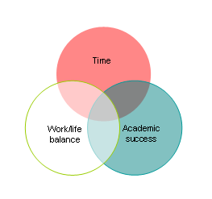
For undergraduate students, pressures of time, successful work/life balance and the desire to perform well were the three key motivational factors identified and the three key benefits that developing good information skills could offer our undergraduate students.
All of this work fed directly into the brief drawn up for our external designers, a Manchester based company called Epigram, who had a previous track record of working with the Library. The four page brief detailed the background to the project, our product, our understanding of our customers, the benefits we sought to offer and our requirements, which were a poster (A4 and A3) and a double-sided leaflet (A5) (see Appendix A). The brief also included:

- PowerPoint slides from newly developed information skills presentations illustrating our existing ideas on appropriate language and design
- Library Newsletters and handbooks
- Copies of successful marketing materials we had identified around the campus
- Mock-up posters showing our own design ideas

The result is an intelligent and visually arresting design inspired by the modern day phenomenon of drowning in a sea of information, complete with nautical images such as a life belt and surfing metaphors. The premise of the design is the simple argument that; if you want more time to spend doing the things that either you want to do (enjoy the social side of being an undergraduate student by playing, eating/drinking, relaxing) or have to do (working, looking after family, etc.), then you need to develop skills that will help you save time on academic activities such as finding and using information to complete assignments.

The campaign was designed to address the fact that students live complicated and busy lives, can feel overwhelmed by the amount of information available and frustrated at the methods available to them to find information effectively, such as the Library and Internet search engines. The promotional materials successfully met this objective by tapping into students’ genuine needs and offering the associated benefits.

Fighting flier with flier
Achieve positive exposure for the Library using promotional materials that challenge the traditional view of the Library

In order to achieve this objective, work was done on how to effectively promote services to undergraduate students and to gauge the success of our current approach to promotion. This was done in a variety of ways:

- Use of focus groups with first and second year students to feedback on existing promotional posters produced by the Library

- Collecting printed promotional materials produced and distributed on campus to students, such as bar and club fliers, leaflets produced by Student Support Services and the University Marketing Department

- A brainstorm workshop with library staff to identify new ways of promoting services to students.
Previously, the Library has not used a strategic approach to promote user education. Posters and leaflets, if produced at all, were produced by library staff using basic word processing packages, for use in individual sites or sections. During the focus groups, students were shown two different A4 posters advertising the same information skills session. One emphasised saving time and producing a better essay; the other emphasised finding journal articles/e-resources (see Appendix B). Both were produced using Microsoft Word, employed black and white clip art images and text in a creative way, and were in keeping with some of the better posters being produced within the Library.

There was a distinct lack of enthusiasm for both posters. A number of students commented on the fact that they looked unprofessional and unbranded, had no colour, were too wordy and were boring. One student noted that he would read only the first line, and another said that, if she saw the posters in the Library she would assume that the session wasn’t relevant to her, whereas if she saw them in the department she might consider it relevant. Another student said:

“The graphics on both posters are unclear, need colour and need to look much more professional. I wouldn’t even read it because of [the] poor quality. ..you need to catch the eye with a single word”³

When we considered these comments and previous examples of library promotional material, the stark truth emerged that we were, by and large, failing to get our message across to students and academic staff. This was for a number of reasons, including a failure fully to understand and address the motivations of our users. We had also failed to challenge significantly the perception of some users that our marketing activities were, at best, irrelevant and, at worst, invisible.

These points were built into the design brief. As a result the poster and leaflet deliberately do not look or feel like traditional library publicity. There are no background shots of books or someone working away at a PC. The design uses images and text in a striking and fun way and represents positive and energetic portraits of students – images far removed from the stereotypical view of a library service.

The materials are popular with both students and academic staff alike. Student comments were gathered when the poster designs were initially created. Numerous students thought that the design was “eye-catching”, and other comments suggested that the poster was “like an advert”, and that the designs “didn’t seem like the library”.⁴ Comments from academic colleagues have also been extremely positive. They include:

“The InfoSkills publicity really appeals to our students..”
Kate Kirk, Senior Learning and Teaching Fellow, Institute of Education, MMU

“It is really pleasing to see the Library promoting its services in this way…making students more aware of the accessibility of library resources.”
Rose Heron, Lecturer, Institute of Education, MMU

“It’s [InfoSkills] friendly, accessible and very creative design has ‘hooked’ students into library research in a way I wouldn’t have thought possible.”
Anna Lee, Senior Lecturer, MMU Business School

“…clear branding and constant reminders in the shape of posters in corridors etc. are important “
Mark Stubbs, Senior Lecturer, MMU Business School

The new InfoSkills promotional materials are a considerable success in achieving the objective of positive exposure. Our market research showed that students are exceptionally perceptive and savvy about what they do and don’t like in terms of promotional materials. They do respond well to material that is professionally produced and well-designed. In order to satisfy this discernment, the posters and leaflet were professionally printed on 150g gloss paper using four colours, to ensure excellent quality in the finish and feel.

Through careful consideration of our users, a design was created that was eye catching, intelligent, humorous and engaging. Not only does the design promote a key service offered by the Library, it also represents the Library as a dynamic service, in tune with students’ needs, image conscious and forward thinking. As further evidence of success, we are now working on a new set of promotional materials, developed in a similar way, to promote InfoSkills to postgraduate students.

Read all about it
Increase awareness of information skills teaching to undergraduate students and their academic tutors

The use of the promotional materials began in September 2003 and will continue to be used next academic year. In less than a year, there is growing evidence that InfoSkills is being accepted as a brand identity amongst students and academic staff at MMU.

Before the InfoSkills Project, library staff relied on word of mouth and liaison activities to raise awareness of user education with students and staff. Communication varied among different subject areas, and library staff often struggled with how best to promote services in an appealing and comprehensible manner.

The profile of information skills teaching has dramatically increased throughout the University. A first year student who attends a library induction, logs onto the Library Website, walks past a departmental notice board, or loiters by a ‘what’s on’ notice in a canteen or bar on campus, will see the striking poster image of InfoSkills.

Library induction for first year students was identified as our key marketing opportunity for InfoSkills aimed at undergraduate students. All induction packs, containing key information for orientation, also included the InfoSkills leaflet. Approximately 12,000 induction packs were distributed to MMU students in the first three months of the new academic year. This achieved huge initial exposure to first year students, which was built on later in the second term, when the posters were released to library staff to display throughout the campus. The timing was carefully planned to coincide with increased workload on students and a timely reiteration of the InfoSkills message.

Awareness has also been raised amongst academic colleagues. Library staff have used the leaflet and poster in a number of situations including programme committee meetings, one-to-one updating sessions and academic staff inductions. Library staff have also spoken at faculty learning and teaching awareness events and internal conferences, in order to generate debate and interest in InfoSkills. All issues of Library News, the Library’s newsletter, have included promotion of InfoSkills and a number of contributions have been made to the University wide ‘Learning and Teaching in Action’ journal. Academic support has been a real success. The promotional materials have generated interest and enthusiasm for InfoSkills. Comments include:

“It [InfoSkills] has succeeded in stimulating students’ interest in discovering sources beyond Google – and that’s saying something!”
Anna Lee, Senior Lecturer, MMU Business School

“[InfoSkills] would have no value…if staff and students don’t know about it”
Vivian Sheard, Undergraduate Programme Coordinator, MMU Business School

The combined effort of promoting InfoSkills to both students and academic staff means that 298 information skills sessions have been run this academic year (03/04), with an estimated 9,180 students receiving information skills training to date. Last year 5,993 students were involved in user education session. Therefore, this figure represents a 53% increase this academic year.

Work on maximising the initial upsurge of interest and increasing this number next academic year is underway. Already the MMU Business School has committed to integrating InfoSkills teaching into the curriculum for all 1500 first year undergraduate students in 2004/05. InfoSkills will also be integrated into the Foundation Year course from September 2004, reaching 600 students.
What’s in a name?
Develop a consistent and branded approach to the promotion of information skills teaching

Key to increased awareness has also been the successful branding of InfoSkills at MMU. Library and information literature is rich with accounts of how difficult academic libraries have found communicating the idea of information literacy to students and particularly to academic staff. For this reason we decided to keep the language and message simple and direct. A number of academic colleagues have commented on the effectiveness of the branding of InfoSkills, for example:

“The branding of the project and the techniques used to make both staff and students aware of it have worked very successfully here at the MMU Business School…”
Vivian Sheard, Undergraduate Programme Coordinator, MMU Business School

The term ‘Information skills’ or “InfoSkills” was chosen over ‘Information literacy’ as the preferred term to use with students and staff, in order to aid understanding and avoid any negative connotations that the term ‘literacy’ may evoke. An InfoSkills logo and brand identity colours have been designed and are consistently used by library staff across seven different sites in Manchester and Cheshire. They are used in all promotional materials and teaching materials including PowerPoint presentations, online tutorials and printed hand-outs.

Having professionally designed and produced promotional materials has enabled us to ‘recycle’ the materials in many ways. Images of the poster and leaflet have been used extensively in the Library Newsletter and in PowerPoint presentations aimed at academic staff. In this way we have found it easy to convey our message and achieve a level of credibility with both staff and students alike. One tutor puts it like this:

“...the InfoSkills concept is a brand that needs managing. It is beginning to deliver real benefits for students…and whilst embedding it in core units is essential to ensuring success, it is important that students recognise these skills for what they are: InfoSkills.”
Mark Stubbs, Senior Lecturer, MMU Business School

The branded approach has had a direct effect on library staff confidence in promoting information skills teaching to staff and students. Staff like and feel proud of the promotional materials. They think that they look professional and effectively represent the service they are involved with. Their comments include:

“I think the posters are great, they grab the students’ attention and are unlike anything the Library has given out to them before - the modern bright pictures pull their attention in and before they know it they are reading about the Library!”
Nicola Wakefield, Law Librarian, MMU

“Personally I really like them. I think they make the Library look professional and they outshine other leaflets and posters we produce…[we] come across in a friendly way without being too cheesy.”
Rosie Jones, Senior Assistant Librarian, MMU

“The InfoSkills publicity materials have given the Library much more credibility with academic colleagues”
Jayne Evans, Library Service Manager, MMU

“I don't worry about handing out the leaflets like I have done in the past as I feel that they aren't going to be ignored and that students will take notice of them (not a waste a paper!)”
Subject Librarian, MMU

The project objectives have all been achieved. However, the success of the promotional campaign has prompted us to continue with work in this important area. In the future we would like to spend more time conducting market research on the effectiveness of the promotional materials produced, and look at news ways of promoting InfoSkills directly to postgraduate students and academic staff.
3. PROJECT BUDGET BREAKDOWN

Design & print costs
PROMOTIONAL ELEMENT | COST
Student focus groups to test out existing promotional materials produced by the Library (recruited from the Student Union Job Shop) | £91.89
Design and artwork for the poster and leaflet | £577.50 +VAT
Printing costs for 15,000 A5 leaflets | £445.00 +VAT
Printing cost for 500 A4 posters and 100 A3 posters | 339.00 +VAT
TOTAL COSTS | £1,453.39

Staff costs
ACTIVITY | NUMBER OF STAFF | STAFF TIME
Library staff sharing of experience session (user needs analysis) | 18 (various levels incl. Library Service Manager and Assistant Librarian) | 3 hours
Marketing brainstorm session | 8 (Senior Assistant Librarians, Assistant Librarians & Library Assistants) | 2 hours
Market research with students (poster/leaflet design) | 1 (Senior Assistant Librarian) | 3 hours
Responsibility for coordinating marketing activities within the InfoSkills Project | 1 (Senior Assistant Librarian) | 3 days per week for first three weeks of marketing activity, then on average 0.5 day per fortnight for one year
4. DETAILS OF PRINTED MATERIALS PRODUCED

Key printed materials (Originals enclosed)
 | The InfoSkills logo and branding have been used widely on all training materials, including PowerPoint slides, WebCT tutorials, hand-outs and on all promotional materials including posters, leaflets and the Library Newsletter. The term ‘InfoSkills’ is now widely used and understood by all library staff and growing numbers of academic and support services staff and students throughout the University.
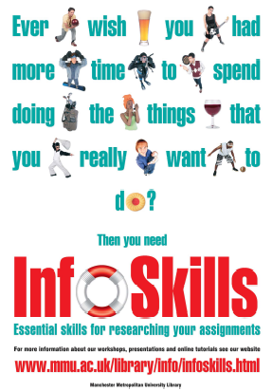 | The posters were printed in two sizes to maximise available display spaces throughout the University. 500 x A4 posters and 100 x A3 posters were printed.  Posters have been displayed widely throughout the seven campuses in academic department buildings (students’ information notice boards), student canteens, the Students’ Union, IT suites and in the Library. Posters have also been used in displays for visit days aimed at prospective students.
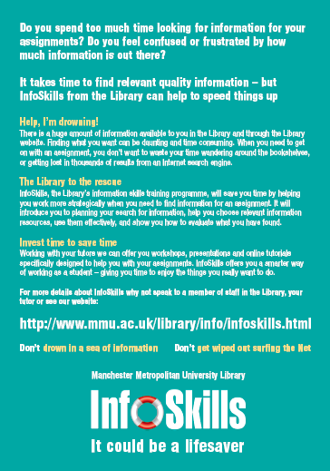  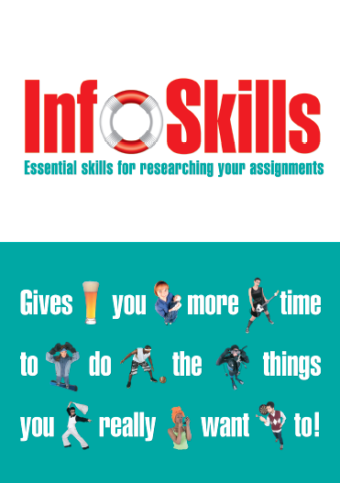 | The double-sided leaflet was designed as an A5 flier. 15,000 x copies were printed. A copy was placed inside every information pack and distributed at all library inductions for new students (approximately 12,000 packs).  Leaflets have been given out at Programme committee meetings to academic staff and student representatives. Leaflets have also been distributed at a number of internal academic staff development events, such as Learning and Teaching Conferences, and at external presentations to library colleagues in the UK and abroad.
Recycled use of printed materials
In order to maximise effort and exposure, the promotional materials, including the poster, logo and brand colours, have been recycled and re-used in numerous ways (Originals enclosed):

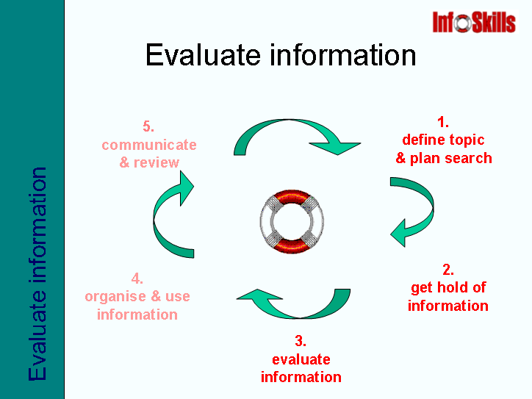  PowerPoint presentation | 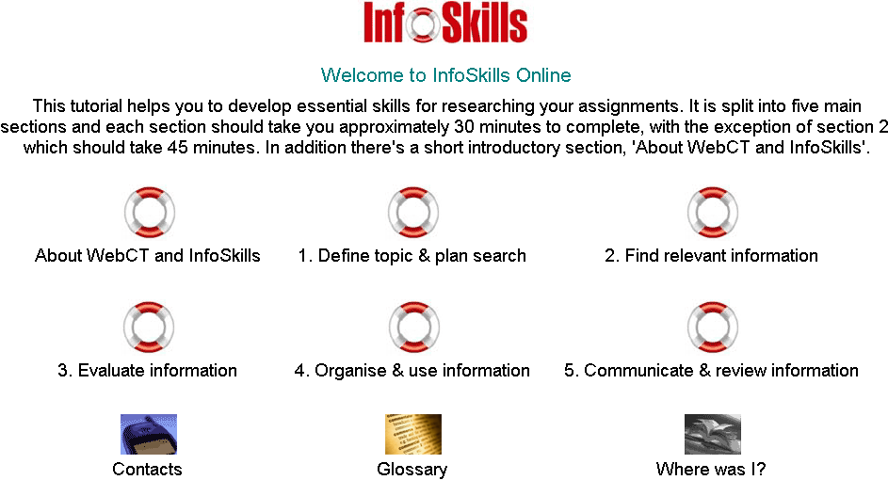  WebCT online tutorial
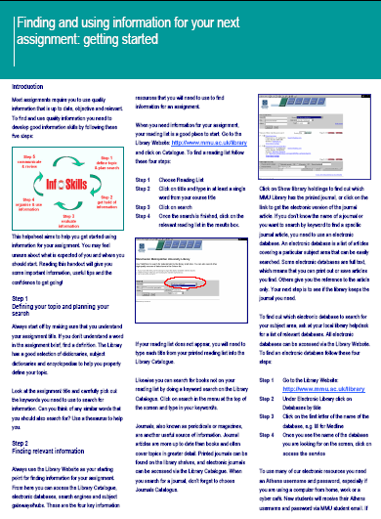  InfoSkills hand-out | The logo, brand colours and design are used in all teaching materials including PowerPoint slides, WebCT online tutorial, webpage design and library leaflets. The professional and branded approach has improved student and academic staff perception of information skills teaching and increased participation and motivation amongst students.
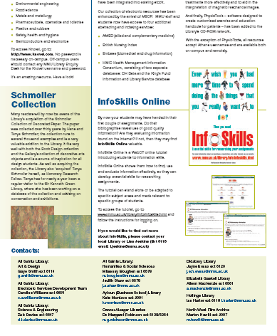  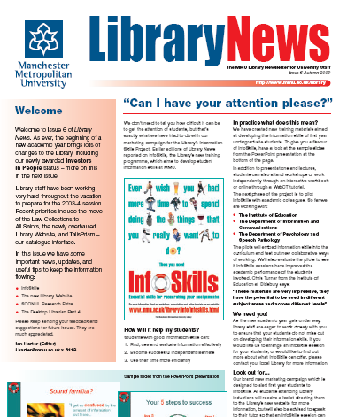 | InfoSkills posters have been reproduced in a number of editions of the Library Newsletter, which is distributed to every member of academic staff in the University.  InfoSkills branding has also been included in numerous presentations by library staff to academic colleagues and other library staff beyond MMU.

References

- MURTAGH, Jackie and Caroline Williams. (2004) ‘Tell me what you want, what you really, really want!’ Developing students’ information skills at Manchester Metropolitan University (MMU) Library, by asking the right questions, and giving the right answers. New Review of Academic Librarianship, 9, pp. 101-112.

- MURTAGH, Jackie and Lisa Jeskins. (June 2003) Interviews with MMU students for user needs analysis. Unpublished document.

- MURTAGH, Jackie and Lisa Jeskins. (June 2003) Interviews with MMU students for user needs analysis. Unpublished document.

- MURTAGH, Jackie and Lisa Jeskins. (August 2003) Market research on poster proofs. Unpublished document.

